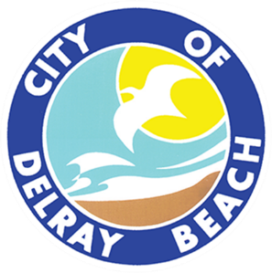
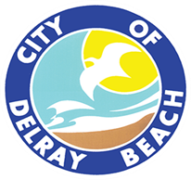
CITY OF DELRAY BEACH
CITY ATTORNEY’S OFFICE
200 NW 1ST Avenue, Delray Beach, FL 33444
561-243-7090

LEGAL REVIEW FORM

This form is to be used solely for the legal review of documents not including procurement agreements. Procurement Agreements are reviewed under a separate cover. This form shall only be completed by a member of the City Attorney’s Office.
Date of Review: 12/05/2024

Document Name: Landscape Maintenance Agreement

Document Type: City’s standard maintenance agreement permitting Edwards Intracoastal, LLC, to install and maintain landscaping within portion of FDOT right-of-way bordering 777 E. Atlantic Avenue.

Submitted by: Amy Alvarez

This document is approved as to form and legal sufficiency.

This document is approved as to form and legal sufficiency; however, the undersigned made the

following change(s):

This document is not approved as to form and legal sufficiency for the following reason(s):

________________________________________________________________________________.

Notes:
Agreement is only valid if/upon the City and FDOT entering into a MMOA permitting landscaping and related improvements to be installed in FDOT right of way.

s/William M. Bennett, Esq.
Assistant City Attorney

Copy to:
_ City Attorney’s Office (with a copy of the approved document)
X Other: Amy Alvarez

