PLANNING AND ZONING BOARD STAFF REPORT
Overhead Doors in Industrial Zoning Classifications
Meeting | File No. |  | Application Type
January 27, 2025 | 2025-103-LDR |  | Amendment to the Land Development Regulations
Applicant
City of Delray Beach

Request
Provide a recommendation to the City Commission on Ordinance No. 09-25, a City-initiated amendment to Section 4.4.19, “Mixed Industrial and Commercial (MIC) District,” Section 4.4.20, “Industrial (I) District,”, Section 4.4.26, “Light Industrial (LI) District,” of the Land Development Regulations (LDR) to amend regulations for overhead doors.
Background Information
The Mixed Industrial and Commercial (MIC) District, Industrial (I) District, and Light Industrial (LI) District restrict the use of overhead doors, with regulations varying in stringency by zoning district:

- MIC. Overhead doors may not face a public right-of-way.
- Industrial (I). Overhead doors shall be prohibited from facing the right-of-way of an arterial or collector street.
- LI: Overhead doors shall not face adjacent rights-of-way except when it is clearly demonstrated that no opportunity exists to do otherwise.

Waivers to allow overhead doors were processed and approved for several properties in the MIC zoning district. Details of the request are summarized below:

1201 Georgia Street  (Granted on February 21, 2017) | Galaxy Marble  (Granted on May 16, 2023) | 1215 Milfred Street  (December 10, 2024)
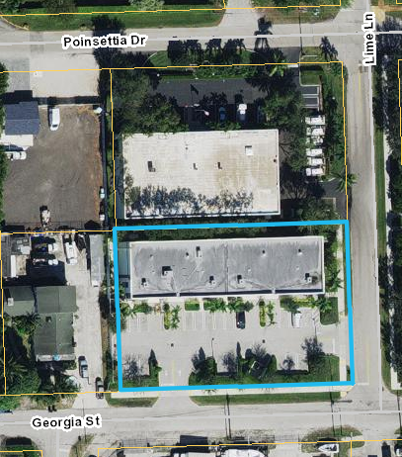 | 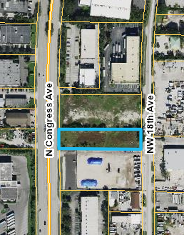 | 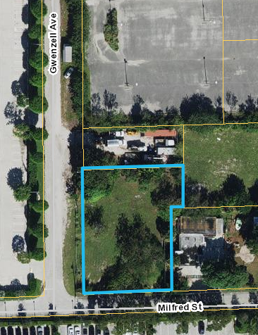

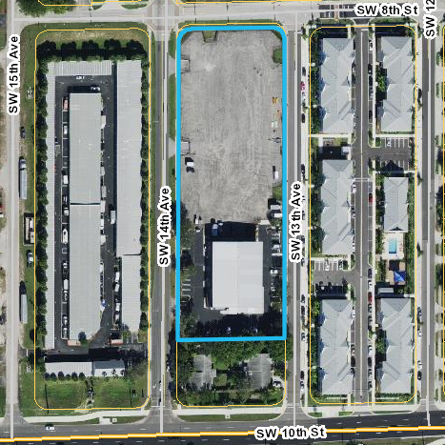
A fourth waiver for the use of the overhead doors at 905 SW 14th Avenue in the LI zoning district (image at right) was presented to the Planning and Zoning Board (PZB) on January 27, 2025 (outcome to be determined).

Although the majority of the overhead door waivers processed by the City were in the MIC zoning district, the City is proposing an amendment to the overhead door restriction in all industrial zoning districts to proactively create standards more conducive to industrial type development.

Description of Proposal
The following changes are proposed:

- Section 4.4.19, MIC

Overhead doors may shall not face a public an adjacent minor arterial right-of-way, residential zoning district, or residential use.

- Section 4.4.20, Industrial

Overhead doors shall be prohibited from facing the right-of-way of an arterial or collector street not face an adjacent minor arterial right-of-way, residential zoning district, or residential use.

- Section 4.4.26, LI

Overhead doors shall not face adjacent rights-of-way except when it is clearly demonstrated that no opportunity exists to do otherwise an adjacent minor arterial right-of-way, residential zoning district, or residential use.

The full text of Ordinance No. 09-25 is provided as an attachment.

Review and Analysis
LDR Section 1.1.6, Amendments
The text of these Land Development Regulations may from time to time be amended, changed, supplemented, or repealed. No such action however, shall be taken until a recommendation is obtained from the Planning and Zoning Board and until a public hearing has been held by the City Commission.

LDR Section 2.4.7(A), Amendments to the Land Development Regulations, amendments to the LDR may be initiated by the City Commission, Planning and Zoning Board, or City Administration, or by a member of the public.

The proposed amendment is City-initiated at the direction of Commission at their December 10, 2024 meeting.

LDR Section 2.4.7(A)(5), Findings
For any approval, the City Commission must make a finding that the text amendment is consistent with the Comprehensive Plan, and that the amendment furthers the implementation of an adopted neighborhood plan, if applicable.

The following Objectives and Policies of the adopted Comprehensive Plan are applicable to the proposed amendment.

Neighborhoods, Districts, and Corridors Element
Objective NDC 3.5, Update the Land Development Regulations Regularly review and update the Land Development Regulations to provide timely, equitable and streamlined processes including, but not limited to, building permit processes for residential developments and to accommodate mixed-use developments, address market changes and development trends, and other innovative development practices.

Policy NDC 2.2.5 Maintain public rights-of-way that provide view corridors or vistas to water bodies and, whenever possible, provide features such as benches, landscaping, and trash receptacles to enhance the areas as pocket parks.

Economic Prosperity Element
GOAL ECP 3 INDUSTRY CLUSTERS GROW A DIVERSE AND RESILIENT ECONOMY BY SUPPORTING LEGACY INDUSTRIES AND ESTABLISHING NEW INDUSTRY CLUSTERS THAT ESTABLISH DELRAY BEACH’S ROLE AS A REGIONAL CENTER FOR INDUSTRY AND COMMERCE.

GOAL ECP 4 BUSINESS CLIMATE & COMPETITIVENESS CULTIVATE A MORE BUSINESS-FRIENDLY ENVIRONMENT AND DYNAMIC ENTREPRENEURIAL ECOSYSTEM WHICH ALLOW LOCAL ESTABLISHMENTS TO GROW IN PLACE, ATTRACT NEW INDUSTRY CLUSTERS AND FIRMS AND PRODUCE NEW HOMEGROWN ENTERPRISES.

GOAL ECP 6 ECONOMIC PLACEMAKING PROVIDE THE PROPER BUILT ENVIRONMENT, SPACE DEVELOPMENT AND STRATEGIC INVESTMENTS TO PROTECT AND GROW DELRAY BEACH’S ECONOMIC BASE.

Objective ECP 6.3 Business-ready Environment Create a business-ready environment for existing and emerging industry clusters.

Policy ECP 6.3.1 Review and improve the Land Development Regulations to ensure permitted uses and building requirements align with desirable industry clusters in targeted areas and with the vision of adopted neighborhood revitalization plans.

Policy ECP 6.3.2 Encourage predictability and consistency in the City’s Land Development Regulations, while also allowing for flexibility and creativity in the site development process.

Policy ECP 6.3.3 Promote a culture throughout the City organization that continuously improves the predictability and reduces the cost of the development review process.

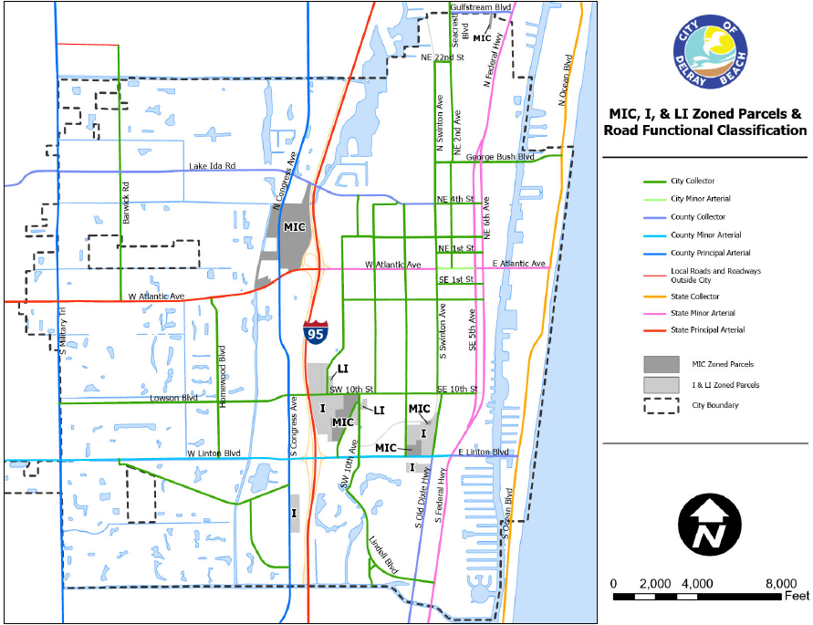
The characteristics of each zoning district and the surrounding conditions are varied. However, the same standards are proposed for each of the three zoning districts.

Generally, overhead doors adjacent to residential uses or residential zoning are considered inappropriate. Overhead doors adjacent to either could expose residential uses to unwanted noise or an unattractive view incompatible with a residential use.

A Collector is defined in the Comprehensive Plan as “Major and minor roads that connect local roads and streets with arterials. Collectors provide less mobility than arterials at lower speeds and for shorter distances. They balance mobility with land access. The posted speed limit on collectors is usually between 35 and 55 miles per hour” (Source: US DOT and FHWA). Lowson Boulevard and Swinton Avenue are considered Collectors.

Within the MIC, LI, and I zoning districts, both Local and Collector roads proliferate. Of the four requested waivers, all four properties have frontage on a Local right-of-way, and one of the subject properties had frontage on both a Local and a Collector right of way. Based on the lot and block pattern within these zoning districts, and the generally well-contained industrial type zoning districts, the prohibition on overhead doors facing either a Collector or Local road is both onerous and largely unnecessary.

The prohibition on overhead doors facing an Arterial is retained and expanded from only Industrial zoning to LI and MIC zoning. I-95 is considered a Principal Arterial, and Minor Arterials are roads such as Linton Boulevard and Congress Avenue. The Comprehensive Plan says that Minor Arterials “provide service for trips of moderate length, serve geographic areas that are smaller than their higher Arterial counterparts and offer connectivity to the higher Arterial system. In an urban context, they interconnect and augment the higher Arterial system, provide intra-community continuity and may carry local bus routes” (Source: US DOT and FHWA). Comprehensive Plan Policy NDC 2.2.5 requires that the City “Maintain public rights-of-way that provide view corridors or vistas to water bodies and, whenever possible, provide features such as benches, landscaping, and trash receptacles to enhance the areas as pocket parks.” On these higher volume roads, it is particularly important to support a more visually appealing built environment.

Reviewing Boards
City Commission. Anticipated for first and second reading in March 2025.
Options for Board Action
- Recommend approval to the City Commission on Ordinance No. 09-25, a City-initiated amendment to Section 4.4.19, “Mixed Industrial and Commercial (MIC) District,” Section 4.4.20, “Industrial (I) District,”, Section 4.4.26, “Light Industrial (LI) District,” of the Land Development Regulations (LDR) to amend regulations for overhead doors, by finding that the amendment and approval thereof is consistent with the Comprehensive Plan and meets the criteria set forth in Land Development Regulations.

- Recommend approval to the City Commission of Ordinance No. 09-25, as amended, a City-initiated amendment to Section 4.4.19, “Mixed Industrial and Commercial (MIC) District,” Section 4.4.20, “Industrial (I) District,”, Section 4.4.26, “Light Industrial (LI) District,” of the Land Development Regulations (LDR) to amend regulations for overhead doors, by finding that the amendment and approval thereof is consistent with the Comprehensive Plan and meets the criteria set forth in Land Development Regulations.

- Recommend denial to the City Commission of Ordinance No. 09-25, a City-initiated amendment to Section 4.4.19, “Mixed Industrial and Commercial (MIC) District,” Section 4.4.20, “Industrial (I) District,”, Section 4.4.26, “Light Industrial (LI) District,” of the Land Development Regulations (LDR) to amend regulations for overhead doors, by finding that the amendment and approval thereof is not consistent with the Comprehensive Plan and does not meet the criteria set forth in Land Development Regulations.

- Continue with direction.
Public and Courtesy Notices
_X_ Courtesy Notices are not required. |  | _X_ Public Notices are not required for this request.

