ORDINANCE NO. 04-25

AN ORDINANCE OF THE CITY COMMISSION OF THE CITY OF DELRAY BEACH, FLORIDA, AMENDING THE LAND DEVELOPMENT REGULATIONS OF THE CITY OF DELRAY BEACH CODE OF ORDINANCES CHAPTER 4, “ZONING REGULATIONS,” ARTICLE 4.3, “DISTRICT REGULATIONS, GENERAL PROVISIONS,” SECTION 4.3.3, “SPECIAL REQUIREMENTS FOR SPECIFIC USES,” TO ADOPT SUBSECTION (DDD), “RETAIL TOBACCO AND NICOTINE PRODUCTS DEALER,” TO ENACT REGULATIONS GOVERNING THE LOCATION AND OPERATIONS OF RETAIL TOBACCO AND NICOTINE PRODUCTS DEALERS; AND BY AMENDING ARTICLE 4.4, “BASE ZONING DISTRICT,” SECTION 4.4.13, “CENTRAL BUSINESS (CBD) DISTRICT,” SUBSECTION (C), “ALLOWABLE USES,” TO ADOPT DISTANCING REQUIREMENTS FOR STANDALONE RETAIL TOBACCO OR NICOTINE PRODUCTS DEALERS, AND BY AMENDING APPENDIX A, “DEFINITIONS,” TO ADOPT A DEFINITION FOR RETAIL TOBACCO OR NICOTINE PRODUCTS DEALERS; PROVIDING A CONFLICTS CLAUSE, A SEVERABILITY CLAUSE, AUTHORITY TO CODIFY, AND PROVIDING AN EFFECTIVE DATE.

WHEREAS, the Land Development Regulations (“LDR”) of the City of Delray Beach (“City”) Code of Ordinances provide authority for the City Commission to amend, change, supplement, or repeal the LDR from time to time; and

WHEREAS, multiple standalone retail tobacco and nicotine products dealers have begun to concentrate on Atlantic Avenue; and

WHEREAS, the concentration of standalone retail tobacco and nicotine products dealers on Atlantic Avenue reduces the economic diversity of the traditional downtown and impacts the family-friendly atmosphere; and

WHEREAS, it is advisable to regulate the proximity of standalone retail tobacco and nicotine products dealers to residential zone districts, schools, public parks, daycare facilities, and places of worship in light of warnings issued by the U.S. Centers for Disease Control and Prevention on the negative impact of tobacco use; and

WHEREAS, it is in the best interest of the City to adopt regulations governing retail tobacco and nicotine products dealers; and

WHEREAS, pursuant to Florida Statutes 163.3174(4), the Planning and Zoning Board for the City of Delray Beach, sitting as Local Planning Agency, considered this item at a public hearing on April 21, 2025, and voted 6 to 0 to recommend that the proposed text amendments be approved, finding that the request and approval thereof is consistent with the Comprehensive Plan and meets the criteria set forth in the Land Development Regulations; and

NOW, THEREFORE, BE IT ORDAINED BY THE CITY COMMISSION OF THE CITY OF DELRAY BEACH, FLORIDA, AS FOLLOWS:

Section 1. The recitations set forth above are incorporated herein.

Section 2. The City Commission of the City of Delray Beach finds this Ordinance is consistent with the Comprehensive Plan, meets the criteria set forth in the Land Development Regulations, and is in the best interests of the City.

Section 3. Chapter 4, “Zoning Regulations,” Article 4.3, “District Regulations, General Provisions,” Section 4.3.3, “Special requirements for specific uses,” of the Land Development Regulations of the City of Delray Beach, Florida is amended to adopt Subsection (DDD), “Retail Tobacco and Nicotine Products Dealer,” as follows:

(DDD) Retail Tobacco and Nicotine Products Dealer.

(1) Purpose and intent. The purpose of this section is to regulate the location and operation of Retail Tobacco and Nicotine Products Dealers to protect the unique character and aesthetic of the City; for the public health, safety, and welfare of all residents and visitors; and the administration of local laws.

(2) Prohibition by Frequency. Standalone Retail Tobacco and Nicotine Products Dealers shall not be located within 750 feet of another such use as measured from lot line to lot line. This restriction does not apply to a duly licensed grocery store, convenience store, or pharmacy that sells tobacco and nicotine products.

(3) Prohibition by Proximity. Standalone Retail Tobacco and Nicotine Product Dealers shall not be located within 300 feet of an established residential zone, school, public park, daycare facility, or place of worship as measured from property line to property line. This restriction does not apply to a duly licensed grocery store, convenience store, or pharmacy that sells tobacco and nicotine products.

(4) Limitations.

(a) CBD Oil. The sale of cannabidiol products is regulated by Section 4.3.3(CC), with such regulations determining if cannabidiol products may be sold by a standalone Retail Tobacco and Nicotine Products Dealer.

(b) Signage. Exterior signage, including window signage, specifically advertising tobacco and nicotine products is prohibited, unless such wording is part of the business name.

(c) Window Displays. Window displays of tobacco and nicotine products and accessories are prohibited.

(d) Hours of operation. Standalone Retail Tobacco and Nicotine Product Dealers are limited to operating between 8 a.m. to 10 p.m.

Section 4. Chapter 4, “Zoning regulations,” Article 4.4, “Base Zoning District,” Section 4.4.13, “Central Business (CBD) District,” Subsection (C), “Allowable Uses,” of the Land Development Regulations of the City of Delray Beach, Florida is amended as follows:

(C) Allowable uses.

(1) - (2) (These subsections shall remain in full force and effect as adopted.)

(3) Required Retail Frontage Use Limitations. Streets designated on the Regulating Plan with Required Retail Frontage are intended to be lively, highly active pedestrian environments that support businesses and reinforce local character. Properties on streets designated with Required Retail Frontage have use and frontage type standards that apply to the sidewalk level story.

(a) All Sub-districts.

1. Residential units, including multi-family and live-work, are not permitted in the sidewalk-level story on streets with Required Retail Frontage.

2. On streets with Required Retail Frontage, buildings and uses at the sidewalk level shall comply with the following:

a. The frontage type shall be either a Storefront or Arcade with a Storefront. See Section 4.4.13(E);

b. The width of an individual commercial space shall not exceed 75 feet (See Figure 4.4.13-C-2);

c. The depth of an individual commercial space shall be at least 20 feet and contain only uses permitted in 4.4.13(C)(3)(b) and (c); combinations of permitted uses with other uses not permitted at the sidewalk level are not allowed (See Figure 4.4.13-C-2); and

d. Uses not permitted in 4.4.13(C)(3)(b) and (c) shall not be accessed from the street designated with Required Retail Frontage and must be physically separated with no interior connections between common walls (See Figure 4.4.13-C-2).

3. Valet and passenger loading areas and access are not permitted.

Figure 4.4.13-C-2 Required Retail Frontage
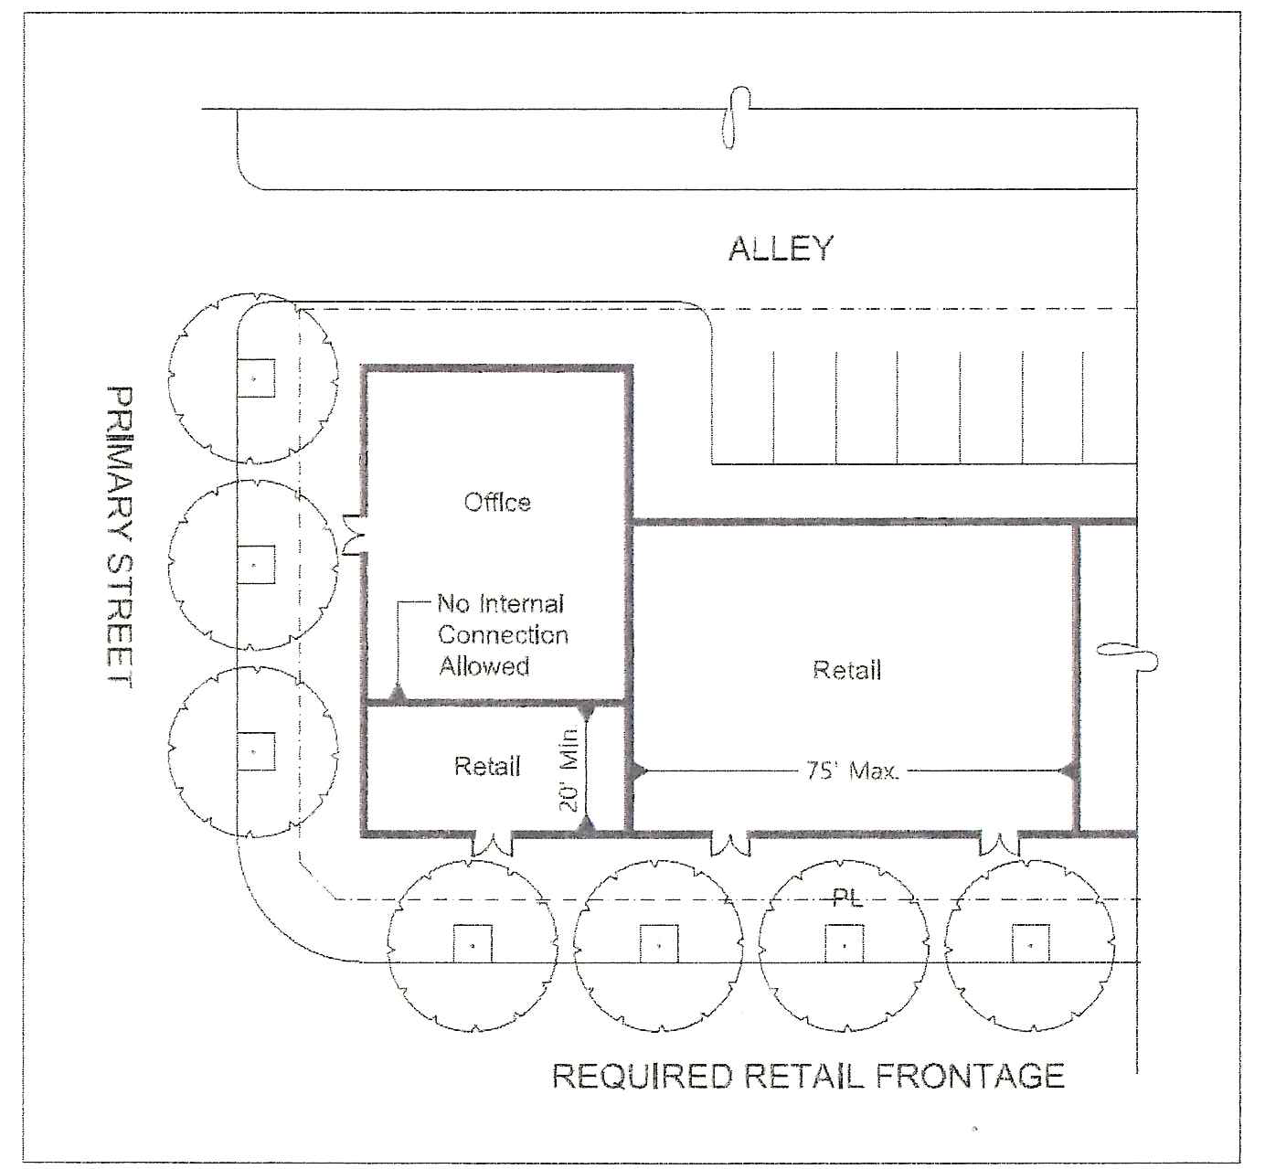

(b) Central Core and Beach Sub-districts. One hundred percent of the building frontage at the sidewalk-level story shall be for the following uses (as described in Table 4.4.13(A)):

1. General retail uses and/or facilities.

2. Services and facilities.

3. Hotels, motels, or residence-type inns.

4. NEV sales, lease or rental offices.

5. Limitations and exceptions.

a. Tattoo establishments are not permitted.

b. Financial institutions are limited to banks and savings and loan establishments; brokerage firms and private wealth management firms are not permitted. The following regulations also apply:

i. No more than 75 feet of financial institution frontage is allowed per block face; and

ii. No more than a total of 100 feet of financial institution frontage is allowed on facing street frontages. (For example, a new financial institution with 30 feet of street frontage may locate across the street from an existing financial institution with 70 feet of street frontage.)

c. Sale of automotive parts, lawn care equipment, firearms, or secondhand material (other than verifiable antiques) are not permitted.

d. Buildings constructed prior to 1980 located in the Beach Sub-district that have 80 percent or more of their frontage at a setback of 25 feet or greater shall be exempted from the 100 percent ground floor retail requirement.

e. CBD oil establishments as a principal use, or the sale of CBD oil products as an accessory use are not permitted.

f. Eyeglass stores with accessory optometry services are limited to one store per block face and are not permitted on facing street frontages.

(c) West Atlantic Neighborhood Sub-district.

1. At least 50 percent of the building frontage of the sidewalk level story shall be for the following uses (as described in Table 4.4.13(A)):

a. General retail uses and/or facilities, except that sales of automotive parts, lawn care equipment, firearms, or second hand material (other than verifiable antiques) are not permitted.

b. Services and facilities

c. Hotels, motels, or residential-type inns as a Conditional Use

2. Up to 50 percent of the building frontage of the sidewalk level story may be for business, professional, and medical uses/offices; more than 50 percent may be approved as a Conditional Use.

Table 4.4.13(A)—Allowable Uses and Structures in the CBD Sub-Districts
Uses | Central Core | Railroad Corridor | Beach Area | West Atlantic Neigh.⁵ | South Pairs Neigh
General retail uses and/or facilities, as in GC district (4.4.9)¹ | P | P | P | P | P
Business, professional, and medical uses, as in GC district (4.4.9) | P | P | P | P | P
Services and facilities, as in GC district (4.4.9)² , excluding drive-through facilities | P | P | P | P | P
Multiple-family dwellings³ | P | P | P | P | P
Astrologist, clairvoyants, fortune tellers, palmists, phrenologists, psychic reads, spiritualists, numerologists and mental healers as in GC district (4.4.9) | - | - | - | - | P
Community residences | See 4.4.13(C)(4)(a)
Nursing homes, abused spouse residences, continuing care facilities, and assisted living facilities that do not comport with the definition of "community residence" | P | P | P | P | C
Live/work units (see 4.3.3(KKK)) | P | P | P | P | P
Hotels, motels, and residential-type inns³ (see 4.3.3(M) and 4.3.3 (X)) | P | P | P | C | C
Bed and breakfast inns (see 4.3.3 (Y)) | P | P | P | C | C
Public Parking Garages, as mapped on a Regulating Plan | P,S | P,S | P,S | P,S | P,S
Fabrication and/or Assembly | - | P | - | - | -
Wholesaling, Storage, and Distribution⁴ | - | P | - | - | -
Contractor and trade services | - | P | - | - | P
Automobile brokerage, including vehicle display within an enclosed structure | - | P | - | - | -
Tattoo Establishments (see 4.3.3(ZB)) | P,A | P,A | P,A | P,A | P,A
CBD Oil Establishments (see 4.3.3 (CC)) | P,A | P,A | - | - | -
Family day care homes (see 4.3.3(T)) | A | A | A | A | A
Home-based businesses (see 4.3.3(K)) | A | A | A | A | A
Mechanical parking lifts (see 4.6.9(D)(11) and 4.6.9(F)(4)) | A,S | A | A,S | A,S | A,S
Parking areas, passenger drop-off, loading/unloading, refuse and service areas | A,S | A | A,S | A,S | A,S
Automated Parking Garages | - | S | - | - | -
Refuse and service areas
Recreational facilities (for a multiple-family development) | A | A | A | A | A
Services and repair (incidental to the associated principal use) | A,S | A | A,S | A,S | A,S
Single-family dwelling (occupied by owner, proprietor, or employee of the principal use) | A | A | A | A | A
Storage of inventory (not shared or leased independent of the principal use) | A,S | A | A,S | A,S | A,S
Automobile repair, service | - | C | - | - | -
Neighborhood Automotive Rental facility (See 4.3.3(C)) | - | - | - | - | C
Child care Facilities (see 4.3.3(E)) and adult day care facilities (see 4.3.3(F)) | C | C | C | C | C
Commercial recreational facilities, such as bowling alleys, skating rinks, and amusement game facilities | C | C | C | C | C
Drive-through facilities (serving banks, financial institutions, retail uses, etc.)² See 4.4.13(J)(7)(a) | C | C | C | C | C
Food Preparation and/or Processing including bakeries and catering | - | C | - | - | -
Funeral homes, including accessory uses such as a chapel or crematory | C | C | C | C | C
Gasoline stations (See 4.4.13(J)(7)(b) and/or car washes (See 4.4.13(J)(7)(c)) | C | C | - | - | C
Large family child care homes (see 4.3.3(TT)) | C | C | C | C | C
Dry-cleaning Processing Plants | - | C | - | - | -
Segway tours and Segway sales (see 4.3.3(ZZZZ)) | C | C | C | C | C
Theaters, excluding drive-ins | C | C | C | C | C
Pet Services [See 4.3.3(W)] | C | C | C | C | C
Pet Hotels [see 4.3.3(W)] |  | C |  |  | C
Veterinary Clinics [see 4.3.3(W)] | C | C | C | C | C
24-hour or late-night businesses, within 300 feet of residential zoned property [see 4.3.3(VV)] | C | C | C | C | C
Urban Agriculture [4.3.3 (D)] excluding outdoor Urban Farms | P,A | P,A | - | P,A | P,A
Outdoor Urban Farms [4.4.3(D)] | C | C | C | C | C
Clubs and Lodges as in GC (4.4.9) | - | - | - | - | C
Flea Markets, Bazaars as in GC (4.4.9) | - | - | - | - | C
Sales and service of all terrain vehicles and personal watercraft as in GC (4.4.9) | - | - | - | - | C
Vehicle care (See 4.4.13(C)(4)(f)(5)) | - | - | - | - | C
Churches or places of worship (See 4.4.13(C)(4)(c)) | - | - | - | C | C
LEGEND: P = Principal Use A = Accessory Use C = Conditional Use - = Prohibited Use S = Secondary Street Use

¹ Sales of automotive parts, lawn care equipment, firearms, or secondhand material (other than verifiable antiques) are not allowed on properties facing a designated Required Retail Street on the Regulating Plan or anywhere within the West Atlantic Neighborhood.
² Drive-thru and Drive-in restaurants are not permitted within the CBD.
³ For density limits, see Table 4.4.13(C).
⁴ Not self-storage facilities; products and materials shall not exceed 55 gallons of any substance which is listed on the Generic Substances List of the Palm Beach County Wellfield Protection Ordinance (Ref.: Palm Beach County LDC, Article 9, Section 9.3)
⁵ See Section 4.4.13(C)(4)(a) for limits on commercial use locations in the West Atlantic Neighborhood Sub-district.

(4) Supplemental use standards.

(a) Community Residence Housing. Except as required by state law, a Community Residence housing four to ten individuals shall be allowed as a permitted use in all four CBD Sub-Districts if it (1) would be located at least 660 linear feet from the closest existing community residence housing four or more individuals as measured from the nearest property line of the proposed community residence to the nearest property line of the existing community residence, and (2) the operator or applicant is licensed or certified by the State of Florida to operate the proposed community residence, has certification from an appropriate national accrediting agency, or has been recognized or sanctioned by Congress to operate the proposed community residence. Except as required by state law, a conditional use permit must be obtained for any community residence that does not meet both criteria (1) and (2). See additional and related regulations at Section 2.4.7(G) and 4.3.3(I) of the Land Development Regulations.

(b) Worker transport/assembly points. The picking-up, dropping-off, or otherwise transporting workers, assigned through an employment agency, from an assembly point in the CBD to the work site is prohibited, except within the West Atlantic Neighborhood area provided the structure or assembly point is not located on West Atlantic Avenue.

(c) West Atlantic Neighborhood Sub-district Supplemental Use Standards: The following supplemental district regulations apply in the West Atlantic Neighborhood Sub-district:

1. West Atlantic Neighborhood Commercial Area. Commercial and mixed-use structures may extend up to 150 feet from West Atlantic Avenue and are allowed on NW 5th Avenue and SW 5th Avenue. Residential structures and accessory uses such as parking areas, landscaping, and drainage retention areas may extend beyond the 150-foot limit. Full service grocery stores may extend beyond the 150-foot limit from West Atlantic Avenue with approval by the SPRAB or the HPB of a site plan design that ensures compatible transitions between commercial and residential areas. Establishment or expansion of commercial and mixed-use structures beyond the 150-foot limit may be allowed as a conditional use, subject to the required findings of Section 2.4.5(E)(5). The West Atlantic Neighborhood Commercial Area is mapped on the West Atlantic Neighborhood Regulating Plan.

2. There is no restriction on repair of non-conforming single family residences located more than 150 feet from West Atlantic Avenue.

(d) Railroad Corridor Sub-district Supplemental Use Standards. The following supplemental district regulations apply in the Railroad Corridor Sub-district:

1. Outdoor uses: Within the Railroad Corridor Sub-district, except for outside storage approved pursuant to Section 4.6.6(C)(2) and outdoor dining, all principal and conditional uses shall be conducted within an enclosed building.

2. Automobile brokerages: Inventory must only be located within an enclosed building. Automobiles which are part of the business inventory must not be placed in parking areas.

3. Parking garages, automated: Automated parking garages are allowed on Secondary Streets located north of NE 2nd Street. Automated parking garages are subject to the following requirements:

a. A traffic statement must be provided detailing the ingress, egress, queuing, and circulation demonstrating the specific measures taken to minimize stacking onto public right-of-way resulting from the automated parking garage.

b. An attendant must be on-site during all hours of operation, defined as any time the parking garage is accessible for parking purposes by the public, and the garage must be secured when not accessible for parking purposes. An attendant is not required if the parking garage is limited to private use. i.e, not available to the general public.

c. Projects with driveways that limit the ability to install the required number of street trees shall either provide the required trees at another location on-site or contribute to the Tree Fund, in accordance with the fee schedule in Section 4.6.19(E)(5)(d).

d. The SPRAB may approve automated parking garages that utilize an alternative façade design or cladding materials provided photovoltaic cells (solar panels) are incorporated into the structure and used as a power source for the garage operations or uses associated with the automated parking garage; if solar panels are not incorporated, facades that do not meet the architectural standards in Section 4.4.13(F) require City Commission approval.

(e) South Pairs Neighborhood Sub-district Supplemental Use Standards: The following supplemental district regulations apply in the South Pairs Neighborhood Sub-district:

1. Hotels, motels or residential-type inns shall only be permitted as a conditional use and on sites located between SE 5th Avenue and SE 6th Avenue.

2. Automobile brokerages/rental: Inventory must only be located within an enclosed building and shielded from the primary street. Automobiles that are part of the business inventory must not be stored in public or required parking areas.

3. Astrologists, clairvoyants, fortune tellers, palmists, phrenologists, psychic readers, spiritualists, numerologists and mental healers are limited to no more than one business every 300 feet, measured in a straight line from lot line to lot line.

4. Vehicle care limited to the changing of oil and filters and lubrication, with no mechanical work or outside storage of vehicles, except as part of a gasoline station.

(f) Special Requirements for Specific Uses: Permitted uses that are not specified in Table 4.4.13(A) may also have additional regulations in Section 4.3.3.

(g) Outdoor use areas: All outdoor uses areas, with the exception of accessory uses clearly ancillary to the principal use, are subject to parking requirements. This provision is applicable to balconies, porches, rooftops, and any other outdoor use area regardless of which story it is located.

(h) Rooftop Terraces: These regulations are intended to guide the use of rooftops in the downtown.

1. Rooftop uses. Rooftop terraces may be used for outdoor dining, open-air lounges, exercise and fitness activities (both as principal or accessory uses), rooftop gardens, urban agriculture, and recreational amenities.

2. General Standards for rooftops. All rooftop terraces shall comply with the following standards:

a. Rooftop terraces shall be architecturally compatible with the design of the overall building.

b. Rooftop terraces shall be designed to mitigate potential impacts to surrounding properties.

i. Lighting standards of Section 4.6.8 apply. All rooftop lighting shall be full cutoff luminaries to minimize spillover on adjacent properties. Light poles may not extend beyond the maximum building height limit.

ii. Live music and music played by a disc jockey are not permitted unless within enclosed spaces; and, noise control is subject to the City's Noise Ordinance.

iii. For properties adjoining or separated by an alley from a residential zoning district, OSSHAD, or an existing residential use, rooftop terrace design shall provide screening at least six feet in height along the adjoining perimeter to limit oversight into residential properties. Privacy screening shall not extend above 60 feet and may consist of a parapet, landscape, railings, etc.

iv. Outdoor rooftop activities (not within enclosed areas) are limited on Sunday through Thursday to the time between 7 a.m. and 10 p.m., and on Friday and Saturday to the time between 7 a.m. and 11 p.m.

c. Parking must be provided when a principal use is located on a rooftop terrace. (For example, restaurant seating or an outdoor yoga studio). Parking is not required for amenities that are ancillary to the principal use. (For example, a swimming pool for a condominium).

d. Railings or parapets shall be a minimum of four feet in height, consistent with proposed architectural style, and provided for the full perimeter of rooftop terrace. Railing and parapet height may not extend beyond the maximum building height of 60 feet.

3. Rooftops on Buildings with the Maximum Number of Stories. These regulations are intended to guide the non-habitable use of rooftops for buildings built to the maximum story height limit to allow rooftop terraces. Rooftop terraces and rooftop amenities, such as roof gardens, observation decks, swimming pools, and running tracks, are encouraged to create unique gathering spaces, to aid in the reduction of the urban heat index, and to add aesthetic value to the buildings. Rooftop terraces are not intended to add additional story height. Rooftop terraces shall be subject to the following criteria:

a. Rooftop terraces that are entirely open to the sky may occupy 100 percent of the total gross roof area.

b. Rooftop terraces shall be hardscaped with materials such as, but not limited to, patterned concrete, pavers, or wood decking.

c. Rooftop terraces shall be landscaped over a minimum of ten percent of the rooftop terrace area. Landscaping shall consist of trees, shrubs, ground cover, and vines.

d. Covered structures located above the maximum allowable number of stories are permitted to cover a maximum area of 25 percent of the rooftop terrace area. For the purposes of calculating the maximum area, the term "covered structures" shall not include enclosures for screening mechanical systems, elevator shafts, or stair towers. The following restrictions apply:

i. Covered structures located above the maximum number of stories shall not exceed a maximum height of 60 feet.

ii. The uses within covered structures shall not be for residential or similar use or for uses generally with a 24-hour occupancy. Covered structures that may be climate-controlled are limited to elevator lobby areas, restrooms, restaurants, lounges, fitness centers, and similar uses.

4. Swimming pools on rooftops. Swimming pools and/or hot tubs are permitted in rooftop terraces subject to the following criteria:

a. Swimming pools and hot tubs are only permitted as amenities to residential or hotel buildings.

b. Swimming pools and hot tubs are permitted provided the top of the surrounding deck does not exceed eight feet above the top of the main rooftop.

c. Swimming pools and/or whirlpools shall be surrounded by a minimum five-foot wide walkway.

d. Supporting restroom facilities associated with swimming pools shall comply with the standards for covered structures.

(i) Retail Tobacco or Nicotine Products Dealer. No more than one standalone retail tobacco or nicotine products dealer is allowed per block, and products may not be displayed in the window. Additional and related regulations in Section 4.3.3(DDD) apply.

Section 5. Appendix A, “Definitions,” of the Land Development Regulations of the City of Delray Beach, Florida is amended as follows:

retail tobacco or nicotine products DEALER. A licensee of the Florida Department of Business and Professional Regulation authorized to engage in the retail sale of tobacco products and nicotine products to consumers.

Section 6. All ordinances or parts of ordinances in conflict herewith be, and the same are, hereby repealed.

Section 7. Should any section or provision of this Ordinance or any portion thereof, any paragraph, sentence, or word be declared by a court of competent jurisdiction to be invalid, such decision shall not affect the validity of the remainder hereof as a whole or part thereof other than the part declared to be invalid.

Section 8. Specific authority is hereby given to the City Clerk to codify this Ordinance.

Section 9. This Ordinance shall become effective immediately upon its passage on second and final reading.

PASSED AND ADOPTED in regular session on second and final reading on this ___ day of ___________________________, 2025.

ATTEST:

Alexis Givings, City Clerk Thomas F. Carney, Jr., Mayor

First Reading
Second Reading

Approved as to form and legal sufficiency:

Lynn Gelin, City Attorney

