Planning & Zoning Board STAFF REPORT
Layton Pointe Plat
Meeting | File No. |  | Application Type
April 21, 2025 | 2024-109-PMA-PZB |  | Preliminary Plat and Final Plat
Applicant | Owner |  | Authorized Agent
Toll Southeast LP Company, Inc. | Toll Southeast LP Company, Inc. |  | Brian Terry, PLA, Insite Studio  Christina Bilenki, Esq., Dunay, Miskel & Backman, LLP
Request
Consideration of the Preliminary Plat and recommendation to the City Commission for the certification of the Final Plat, “Layton Pointe”, a 9.34-acre re-plat of a portion of the southwest quarter (SW 1/4) of Section 24, Township 46 South, Range 42 East (fully described in Appendix A), presently addressed as 3900 Sherwood Boulevard.
Background Information
The 9.34-acre subject property, currently addressed as 3900 Sherwood Boulevard, is located south of Lowson Boulevard (immediately south of Sherwood Boulevard), east of South Military Trail, and to the northwest of the Lakeview Golf Course. The Sherwood Park and Lakeview neighborhoods abut the property. The monastery constructed in 1967 was recently demolished, and the parcel is now vacant.

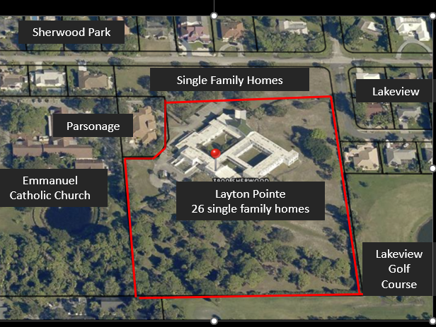
The history of the property is as follows:

1959. The property was annexed into the City and assigned a zoning designation of C-2 “General Commercial”. Following the annexation and the adoption of the City’s comprehensive plan in 1961, a Residential land use designation was assigned, and the subject property was assigned low density residential zoning.

1967. Christ the King Monastery was built.

1990. The subject property was assigned CF zoning during the citywide rezoning effort, at which time the CF district was created.

2007. Pursuant to a request initiated by Christ the King Monastery, 8.27 acres of the property were rezoned back to R-1-AA from CF, and the land use map for the same part of the property was amended from CF to LD (Ordinance No. 59-06). The intent was to develop that portion of the property as single family homes.

2023. The City of Delray Beach requested a corrective land use map amendment (LUMA) for a 1.07-acre portion of the 10.97-acre property to change the land use from Low Density (LD) to Community Facility (CF) to correct a mapping error during the conversion of the Graphic Information System. Ordinance No. 24-23 was approved to make the correction to CF.
2024. A privately-initiated request by the applicant (Toll Brothers) to amend the land use map (File ID 2024-108) redesignating a 1.07-acre portion of a 9.34-acre parcel of land, from CF to LD for the 9.34 acre property (Ordinance No. 32-24), to amend 1.07 acres of the Land Use Map from Community Facility (CF) to Low Density (LD); and, Ordinance No. 33-24, to rezone the entire 9.34-acre property from 1.07 acres of Community Facilities (CF) zoning and 8.27 acres from R-1-AA to R-1-A was approved.
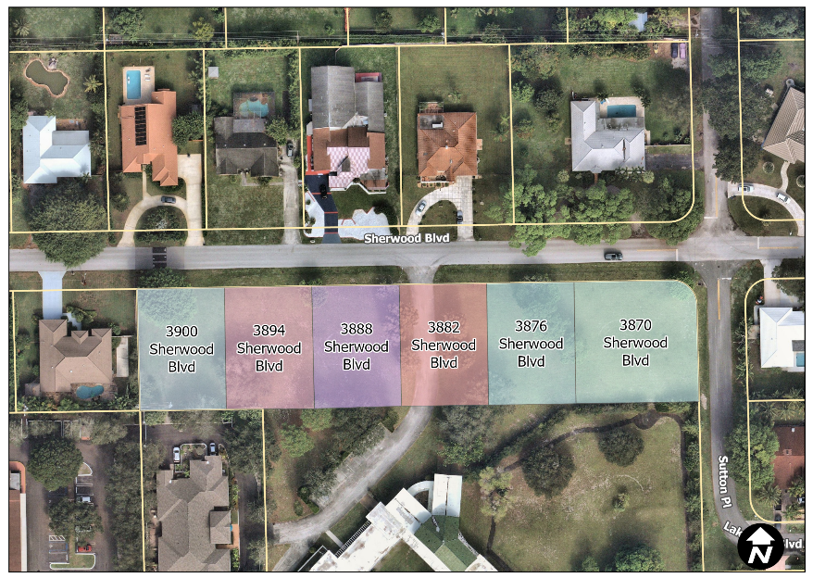
It should be noted that this request does not include the six lots along Sherwood Boulevard (see illustration at left), which retain their R-1-AAA-B zoning. The property, historically known as 3900 Sherwood Boulevard, consists of multiple parcels that were never legally combined through the plat process – most notably, six lots along Sherwood Boulevard, which are the east 73 feet of Lot 7 and the entirety of Lots 8, 9, 10, 11, and 12 of Block 7 of the Replat of Block 7, 8, 9, and 10 of Sherwood Park as recorded in Plat Book 27, Page 161 of the Public Records of Palm Beach County in 1963. The former property owner combined these parcels with the remainder of the property for tax purposes through the Palm Beach County Property Appraiser. The Applicant requested that the property appraiser dissolve the unification for tax purposes, and the City subsequently addressed the parcels shown at right. These lots maintain their original platted configuration that was applied to the four blocks between Military Trail and Dover Road.

Plat Description
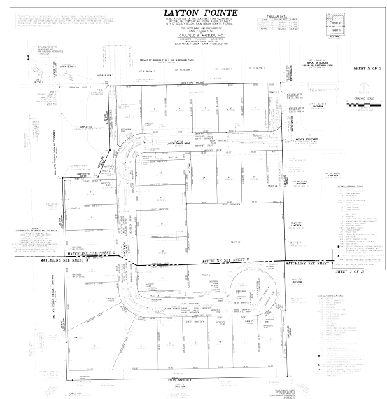
The replat consists of 9.34 acres of land currently addressed as of 3900 Sherwood Boulevard. The Layton Pointe Plat proposes 26 conventional fee-simple single-family lots, with 2.198 acres of open space (image at right, attached full-sized).

The proposed plat includes the following elements:
- Tract R, Right of Way Tract (1.5 acres).
Internal sidewalks are proposed as part of the site plan, and the plat provides sufficient right-of-way (Tract R) for their installation.

- Tracts L1 - L7, Open Space Tracts (2.2 acres).
- Lots 1 – 26, 26 single-family residential lots (5.64 acres).

All lots meet the development standards of the R-1-A district and LDR Section 4.3.4(E) Front and Frontage, as shown on the table below. Lot 26 is restricted on the site plan to a single-story dwelling unit.

The existing utility easements shown on the plat will be abandoned, subsequent to the relocation of the existing water and sewer infrastructure. New water and sewer easements will be recorded, after the new water and sewer infrastructure is constructed.
Lot No. | Lot Width  (60 feet, required) | Lot Depth  (100 feet, required) | Lot Size  (7,500 feet, required)
1, 2 | 65 | 125 | 8,125
3 | 65 | 135 | 8,375
4 | 66 | 135 | 8,375
5 | 67 | 220 | 8,125
6 | 67 | 135 | 9,076
7, 8 | 65 | 135 | 8,775
9, 10 | 67 | 135 | 9,045
11 | irregular | irregular | 12,341
12 | irregular | irregular | 20,790
13 | irregular | irregular | 12,149
14, 15, 17 | 65 | 135 | 8,775
18 | 65 | irregular | 9,530
19 | 65 | 130 | 8,448
20, 21 | 70.50 | 130 | 9,165
22 and 23 | 65 | 130 | 8,450
24 | 65 | 135 | 8,862
25 and 26 | 65 | 135 | 8,775

Review and Analysis
LDR Section 2.4.8(B), Major Subdivision (Platting)
(1) General. The major subdivision process, which generally involves the creation of more than three individual lots, shall involve both the Planning and Zoning Board and the City Commission. The City Commission shall be the final authority in the subdivision review process. The City Commission may approve or deny a plat.

The proposed plat qualifies as a Major Subdivision. The City eliminated the preliminary plat process when Chapter 2 was updated in October 17, 2023, through Ordinance No. 31-23. However, the State recently adopted a regulatory change that requires municipal governments to utilize preliminary plats in certain circumstances. As such, the Board is being asked to approve the preliminary plat to allow the applicant to obtain necessary site development permits prior to the adoption of the final plat by Commission.

(5) Findings. The City Commission must make a finding that the Final Plat is consistent with the Performance Standards in Chapter 3.

A review of the relevant performance standards in Chapter 3 is provided below.

LDR Section 3.1.1, Required Findings
Prior to the approval of development applications, certain findings must be made in a form which is part of the official record. This may be achieved through information on the application, the staff report, or minutes. Findings shall be made by the body which has the authority to approve or deny the development application.

These findings relate to the Land Use Map, concurrency, consistency, and compliance with the Land Development Regulations.

(A) Land Use Map: The resulting use of land or structures must be allowed in the zoning district within which the land is situated and said zoning must be consistent with the applicable land use designation as shown on the Land Use Map.

The subject property has a LUM designation of LD and a zoning designation of R-1-A. Pursuant to the Always Delray Comprehensive Plan, the zoning district is a preferred implementing zoning district of the LD land use designation. Detached single-family residences and related amenities are permitted uses in the R-1-A zoning district.

(B) Concurrency: Concurrency as defined by Objective NDC 3.1 of the Neighborhoods, Districts, and Corridors Element of the adopted Comprehensive Plan must be met and a determination made that the public facility needs, including public schools, of the requested land use and/or development application will not exceed the ability of the City and The School District of Palm Beach County to fund and provide, or to require the provision of, needed capital improvements in order to maintain the Levels of Service Standards established in Table CIE-2, Level of Service Standards, of the Capital Improvements Element of the adopted Comprehensive Plan of the City of Delray Beach.
Schools. The project received a School Capacity Availability Determination (SCAD) letter, concluding that the single-family residences resulting from the proposed plat will not pose a negative impact on the School District of Palm Beach County public school system.

Traffic. The traffic study (performed for 27 units), dated January 29, 2024, considers the anticipated impact from the intended development. 270 new daily trips are anticipated, with 19 AM peak hour trips and 25 PM peak hour trips. Palm Beach County reviewed the study and issued a TPS approval letter (attached).

Water and Sewer. Municipal water and service is available via connections to the existing water and sewer mains located on Sherwood Boulevard and Sutton Place. All sewer connections and all existing water and sewer piping will be required to be inspected prior to making any connections. Pursuant to the Comprehensive Plan, treatment capacity is available at the South Central County Waste Water Treatment Plant for the City at build-out; adequate water and sewer treatment capacity exists to meet the adopted LOS at the City’s build-out population based on the current LUM designation. As noted above, the existing water and sewer easements will be abandoned when the utilities are relocated and new easements are accepted by the City.

Solid Waste. Based on Palm Beach County Waste Generation Rates, a single-family residence generates 1.99 tons of waste per year. Therefore, the approval of the plat would increase the potential solid waste generation by 51.74 tons per year. It is noted that at this time, the landfill serving the property is projected to have sufficient capacity to meet the needs of city residents through the depletion year in 2054.

Drainage. Drainage will be accommodated on site for the entire property, and each lot will be required to accommodate its own drainage. A signed and sealed drainage report and drainage calculations have been submitted to the City for review to ensure compliance with the storm water requirements in accordance with the South Florida Water Management District regulations.

Parks and Open Space. Park impact fees are assessed at $500.00 per dwelling unit and collected prior to issuance of the building permit; 26 additional units = $13,000.

(C) Consistency: A finding of overall consistency may be made even though the action will be in conflict with some individual performance standards contained within Article 3.2, provided that the approving body specifically finds that the beneficial aspects of the proposed project (hence compliance with some standards) outweighs the negative impacts of identified points of conflict.

LDR Section 3.2.1, Basis for Determining Consistency
The performance standards set forth in this Article either reflect a policy from the adopted Comprehensive Plan or a principle of good planning practice. The performance standards set forth in the following sections as well as compliance with items specifically listed as required findings in appropriate portions of Section 2.4.5 shall be the basis upon which a finding of overall consistency [Section 3.1.1(C)] is to be made. However, exclusion from this Article shall not be a basis for not allowing consideration of other objectives and policies found in the adopted Comprehensive Plan in the making of a finding of overall consistency.

The following Objectives and Policies from the Always Delray Comprehensive Plan are applicable to the subject request.

Housing Element

GOAL HOU 2 NEIGHBORHOOD ENHANCEMENT Preserve the integrity of existing stable neighborhoods, stabilize and enhance neighborhoods that are in transition, and revitalize and rehabilitate neighborhoods that have declined.

The subject property is in the area characterized as Stable on the Residential Neighborhood Stabilization map (Always Delray Map AD-5). The proposed single-family residences are compatible with the surrounding low density, single-family, neighborhood.

Policy HOU 1.1.5 Accommodate Delray Beach’s existing and future housing needs through maintenance of existing residential neighborhoods, provision of infill development opportunities and redevelopment of underutilized parcels.

Policy HOU 1.1.7 Foster growth without substantially and adversely impacting existing residential neighborhood character.

Policy HOU 1.1.8 Accommodate densities in established residential areas that promote compatibility with prevailing neighborhood character.

Policy HOU 3.1.4 Encourage development of vacant or underdeveloped land for housing and mixed-uses, and promote rehabilitation of underutilized housing into desirable places to live.

The proposal creates 26 single-family lots on a site that once contained a monastery. The increase in housing units is at a density that is compatible with the surrounding area. The proposed lots are larger than the R-1-A standard, but smaller than the minimum lot size for the R-1-AAAB lots to the north and east (12,500 sf), which may allow for the provision of larger open space areas. The Board should consider if the proposed plat results in compatible use of the land.

Neighborhoods, Districts, and Corridors Element
Objective NDC 1.1, Land Use Designation Establish compatible land use arrangements using land use categories appropriate for the diverse and difference neighborhoods, districts, and corridors throughout Delray Beach.

Policy NDC 1.1.2 Provide a complementary mix of land uses, including residential, office, commercial, industrial, recreational, and community facilities, with design characteristics that provide:
- Similar uses, intensity, height, and development patterns facing each other, especially in residential neighborhoods.
- Uses that meet the daily needs of residents.
- Public open spaces that are safe and attractive.
Policy NDC 1.1.12 Develop and redevelop remaining infill lots in residential neighborhoods using zoning that is identical or most similar to the zoning of adjacent properties or that results in same or less intense development.

Policy NDC 1.1.14 Continue to require that property be developed or redeveloped or accommodated, in a manner so that the use, intensity and density are appropriate in terms of soil, topographic, and other applicable physical considerations; encourage affordable goods and services; are complementary to and compatible with adjacent land uses; and fulfill remaining land use needs.

Policy NDC 1.2.5 Use the Low Density Residential land use designation to create and maintain low density residential neighborhoods up to five dwelling units per acre with high quality amenities.
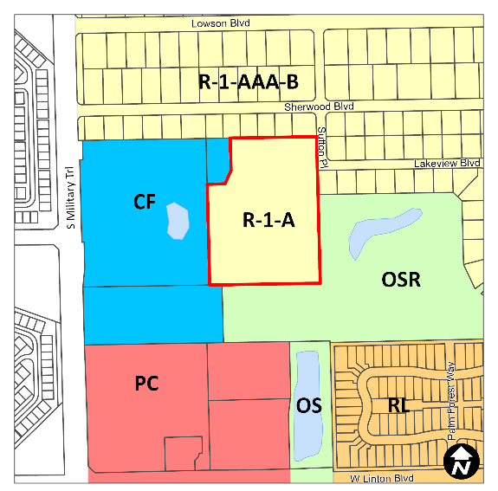
Policy NDC 3.4.2 Use the development review process to determine development, redevelopment, and adaptive reuse is consistent with and complementary to adjacent development, regardless of the implementing zoning designations for each land use designation (See Table NDC-1).

The proposed plat for 26 single-family lots is consistent with the low-density zoning and low-density single-family character of the neighborhood. The LD Land Use permits a maximum density of 5 DU/AC or 46 dwellings on the site, however the plat proposed by the applicant is for 26 single-family lots. The property abuts LD land use to the north, and east, CF land use to the west and OS land use to the south.

LDR Section 3.2.3(A) - (K), Standards for Site Plan and/or Plat Actions

The following standards are applicable to the review of the subject plat.

(A) Building design, landscaping, and lighting (glare) shall be such that they do not create unwarranted distractions or blockage of visibility as it pertains to traffic circulation.

No issues are identified with the proposed plat configuration. These criteria will also be assessed for each new single-family residence during the building permit review process.

(B) All development shall provide pedestrian, bicycle, and vehicular interconnections to adjacent properties, where possible, and include accessible routes from the entry points of publicly-accessible buildings to the sidewalk network in accordance with the Americans with Disabilities Act (ADA).

The proposed configuration provides internal pedestrian access to the open space area and to the streets outside of the development.

The Plat is designed with a cul-de-sac at the southeast end of the plat which provides access to the mail kiosk. It contains three guest parking spaces adjacent to the recreational area to allow safe-pull of to retrieve mail.
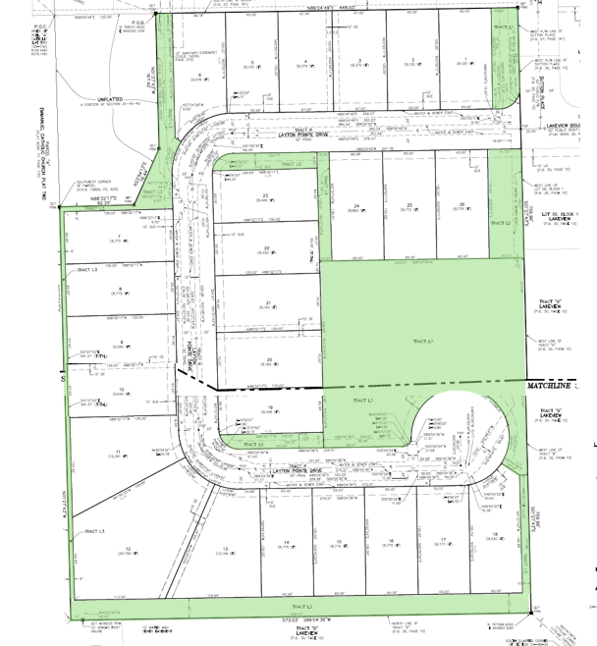
(C) Open space enhancements and recreational amenities shall be provided to meet Objective OPR 1.4 and other requirements of the Goals, Objectives, and Policies, as applicable, of both the Open Space, Parks, and Recreation Element and Conservation Element.

The open space areas are 23.35 percent of the total plat (image at right). The development of each single-family lot will be subject to the minimum open space requirements in the R-1-A zoning district; a minimum of 25 percent non-vehicular open space must be provided on each lot.

Open space Tract L7 has a children’s play area, with benches a walking trail; details will be approved as part of the site plan for the common areas. The applicant has preserved a specimen size Ficus tree (weeping fig) adjacent to the log pile play area, and benches will be provided along a lighted walking trail for access from the north to the play area and the mail kiosk.

(D) Any proposed street widening or modifications to traffic circulation shall be evaluated by the City, and if found to have a detrimental impact upon or result in the degradation of an existing neighborhood, the request shall be modified or denied.
Not applicable. Layton Pointe will have access from Sutton Place directly across from Lakeview Boulevard.
(E) Development of residentially zoned vacant land shall be planned in a manner consistent with adjacent development regardless of zoning designations.
(F) Property shall be developed or redeveloped in a manner so that the use, intensity, and density are appropriate in terms of soil, topographic, and other applicable physical considerations; encourage affordable goods and services; are complementary to and compatible with adjacent land uses; and fulfill remaining land use needs.

The proposed plat is compatible with the surrounding development. The 26 single-family lots result in a density of 2.78 dwelling units per acre, consistent with the low density, single-family character of the neighborhood. The property abuts LD land use to the north, east, and west with lot sizes ranging from 0.35 acres to 0.72 acres. In comparison, Layton Pointe proposes lot sizes ranging from 0.19 acres to 0.47 acres.

(G) Development shall provide a variety of housing types that accommodates the City's growing and socio-economically diverse population to meet the Goals, Objectives, and Policies the Housing Element.

The neighborhood is advertised with home prices starting at $1.4 million, and floor plans with “two-story home designs from 2,632 to 4,187 square feet, 3 to 6 bedrooms, 2.5 to 5.5 baths, 3- to 4-car garages” (Layton Pointe). While the proposed plat expands the inventory of single-family residences, it will serve affluent homebuyers, not a socio-economically diverse mix of residents. The applicant declined to provide attainable units, but the subject property is not within an incentive area where they are required to do so.

(H) Consideration shall be given to the effect a development will have on the safety, livability, and stability of surrounding neighborhoods and residential areas. Factors such as but not limited to, noise, odors, dust, and traffic volumes and circulation patterns shall be reviewed and if found to result in a degradation of the surrounding areas, the project shall be modified accordingly or denied.

The property’s zoning of R-1-A permits single-family residences. Further, the proposed use does not create unsafe or unstable conditions in the neighborhood, nor does the proposed use generate levels of noise, odor, dust, or traffic at higher levels than that of a use permitted by right.
(I) Development shall not be approved if traffic associated with such development would create a new high accident location or exacerbate an existing situation causing it to become a high accident location, without such development taking actions to remedy the accident situation.
According to the traffic statement, the previous use was not generating trips, as it sat vacant for some time, and did not generate much when the property was in use. The traffic study is based on 27 single-family dwellings; 26 dwelling units are proposed. No roadway improvements are required by Palm Beach County as a result of the proposed development.
(J) Tot lots and recreational areas, serving children, teens, and adults shall be a feature of all new housing developments as part of the design to accommodate households having a range of ages. This requirement may be waived or modified for residential developments located in the downtown area, and for infill projects having fewer than 25 units.

The applicant has designed a passive recreational area with some children’s equipment within the development; this will be approved as part of a Level 1 site plan for the common areas.

(K) Development shall not exceed the maximum limits established in the Table NDC-1, Land Use Designations: Density, Intensity, and Implementing Zoning Districts, of the Neighborhoods, Districts, and Corridors Element or specific standards established in the zoning districts that limit density (dwelling units per acre) or intensity (floor area ratio) and must adhere to whichever limit is lower. Development in areas included in density or incentive programs (i.e. workforce housing programs specified in Article 4.7-Family/Workforce Housing) may exceed the Standard density limit, up to the specified Revitalization/Incentive density established for the program; development in all other areas shall not exceed the Standard density.

The intended development consists of 26 dwellings with a density of 2.78 dwellings per acre; the maximum density under LD land use is 5 dwelling units per acre.

(D) Compliance with LDR. Whenever an item is identified elsewhere in these Land Development Regulations (LDRs), it shall specifically be addressed by the body taking final action on a land development application/request. Such items are found in Section 2.4.5 and in special regulation portions of individual zoning district regulations.

LDR Section 4.4.3 – Single Family Residential (R-1) Districts
R-1 zoning provides “areas where the traditional single family detached residence can be established and maintained and be protected from the unwarranted intrusion of other inappropriate uses.” The R-1 districts are established in compliance with Goal HOU 2 of the Housing Element of the Always Delray Comprehensive Plan, which calls for the preservation and maintenance of stable neighborhoods.

The proposed lot dimensions comply with the minimum lot dimensions in the R-1-A zoning district outlined in LDR Section 4.3.4(K), Development Standards Matrix. Each single-family residence will be reviewed by planning and zoning for compliance with the LDR upon application of a building permit.

Technical Notes
- The restriction on Lot 26 should be added to the plat.

Options for Board Action
Preliminary Plat
- Approve the Preliminary Plat, “Layton Pointe”, associated with the creation of 26 fee-simple lots, for the property currently addressed as 3900 Sherwood Boulevard, finding that the request is consistent with the Comprehensive Plan and meets criteria set forth in the Land Development Regulations.
- Deny the Preliminary Plat, “Layton Pointe”, associated with the creation of 26 fee-simple lots, for the property currently addressed as 3900 Sherwood Boulevard, finding that the request is inconsistent with the Comprehensive Plan and does not meet criteria set forth in the Land Development Regulations.
- Continue with direction.
Final Plat
- Recommend approval to the City Commission for the certification of the Final Plat, “Layton Pointe”, associated with the creation of 26 fee-simple lots, for the property currently addressed as 3900 Sherwood Boulevard, finding that the request is consistent with the Comprehensive Plan and meets criteria set forth in the Land Development Regulations.
- Recommend denial to the City Commission for or the certification of the Final Plat for “Layton Pointe”, associated with the creation of 26 fee-simple lots, for the property currently addressed as 3900 Sherwood Boulevard, finding that the request is inconsistent with the Comprehensive Plan and does not meet criteria set forth in the Land Development Regulations.

- Continue with direction.
Public and Courtesy Notices
_X_ Courtesy Notices were sent to the following Homeowner Associations:  - Sherwood Park  - Shady Woods  - Lakeview |  | _X_ Public Notice is not required for this request at Planning and Zoning Board.
Technical Review of Comments (TAC) Timeline
Review No. | Submittal Date | TAC Comments Transmitted
1 | 3/14/2024 | 4/19/2024
Extension Request | 6/5/2024 | Extension until 8/11/2024
Extension Request | 8/12/2024 | Extension until 10/12/2024
2 | 9/17/2024 | 10/11/2024
3 | 11/02/2024 | 12/03/2024
4 | 2/13/2024 | 3/3/2025
5 | 3/13/2025 | 3/28/2025
6 | 4/10/2025

Appendix A: Sketch and Legal Description of 3900 Sherwood

