ORDINANCE NO. 03-25

AN ORDINANCE OF THE CITY COMMISSION OF THE CITY OF DELRAY BEACH, FLORIDA, AMENDING THE LAND DEVELOPMENT REGULATIONS OF THE CITY OF DELRAY BEACH CODE OF ORDINANCES BY AMENDING CHAPTER 4, “ZONING REGULATIONS,” ARTICLE 4.3, “DISTRICT REGULATIONS, GENERAL PROVISIONS,” SECTION 4.3.3, “SPECIAL REQUIREMENTS FOR SPECIFIC USES,” BY ADOPTING A NEW SUBSECTION (PP), “PRIVATE PARKING LOTS;” PROVIDING A CONFLICTS CLAUSE, A SEVERABILITY CLAUSE, AUTHORITY TO CODIFY, PROVIDING AN EFFECTIVE DATE AND FOR OTHER PURPOSES.

WHEREAS, the Land Development Regulations (the “LDR”) of the City of Delray Beach (“City”) Code of Ordinances provide authority for the City Commission to amend, change, supplement, or repeal the LDR from time to time; and

WHEREAS, the City does not currently have regulations governing privately-owned and operated parking lots in the City of Delray Beach; and

WHEREAS, the City has received complaints that privately-owned and operated parking lots appear as if operated by the City and lack pricing transparency; and

WHEREAS, the City desires to adopt regulations that require privately-owned and operated parking lots to install signage that states the parking lot is not operated by the City and clearly reflects the applicable fee to utilize the lot; and

WHEREAS, on December 4, 2024, the Historic Preservation Board voted 7 to 0 to recommend approval of the proposed text amendments to the Planning and Zoning Board; and

WHEREAS, pursuant to Florida Statutes 163.3174(4)(c), the Planning and Zoning Board for the City of Delray Beach, sitting as the Local Planning Agency, considered this item at a public hearing on December 16, 2024, and voted 5 to 0 to recommend approval of the proposed text amendments, finding that the request and approval is consistent with the Comprehensive Plan and meets the criteria set forth in the Land Development Regulations; and

NOW, THEREFORE, BE IT ORDAINED BY THE CITY COMMISSION OF THE CITY OF DELRAY BEACH, FLORIDA, AS FOLLOWS:

Section 1. The recitations set forth above are incorporated herein.

Section 2. The City Commission of the City of Delray Beach finds this Ordinance is consistent with the Comprehensive Plan, meets the criteria set forth in the Land Development Regulations, and is in the best interests of the City.

Section 3. Chapter 4, “Zoning Regulations,” Article 4.3, “District Regulations, General Provisions,” Section 4.3.3, “Special requirements for specific uses,” of the Land Development Regulations of the City of Delray Beach, Florida is amended to adopt a new Subsection (PP), “Private parking lots and garages,” as follows:

(PP) Private parking lots and garages. Private parking lots and garages are defined as any parking facility not owned or operated by the City of Delray Beach or other governmental entities within City limits. Property temporarily being utilized for parking as part of a City-approved special event shall not be considered a private parking lot or garage for the purpose of these regulations.

(1) Required Signage

(a) Lot entrance. One 12-inch x 18-inch parking sign with a blue background and white lettering is required at each entrance outside of the public right-of-way, with a 12-inch x 4-inch sign with a red background and white lettering stating NOT A CITY LOT.

Figure 4.3.3(PP)-1

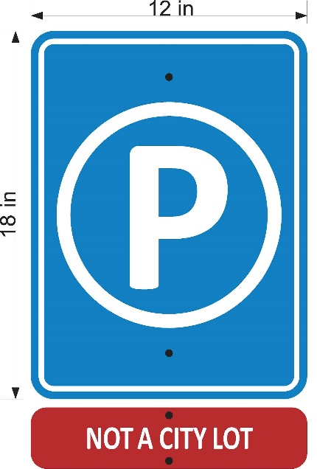

(b) Rate and operator information. An 18-inch x 24-inch sign containing the information listed below shall be prominently displayed internally to the lot that conforms to the example in Figure 4.3.3(PP)-2, along with an 18-inch x 4-inch sign with a red background and white lettering stating, “NOT A CITY LOT.” No more than one sign is permitted for every 10 spaces. One additional sign with the full contract and appeal process is allowed per lot.

Figure 4.3.3(PP)-2

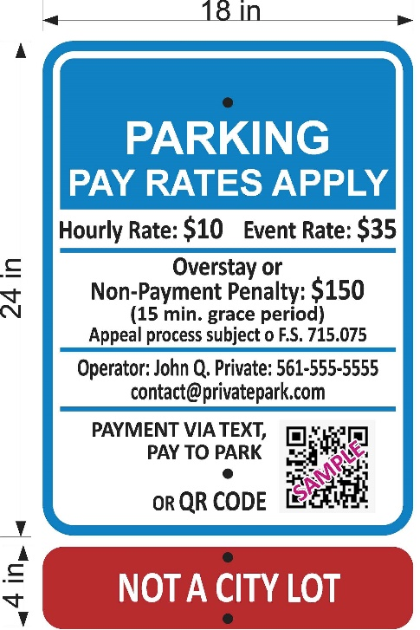

1. Parking rate, including peak hour or special event parking;

2. Charges for violating the posted regulations;

3. A monitored phone number and email address for the operator and vendor(s) issuing violations, immobilization, or towing of vehicles;

4. Notice of a grace period and appeal process;

5. Language that says the lot is not operated by a government entity;

6. A quick-response code (QR) code, mobile app, or text to payment information may also be provided on this sign; and

7. Payment vendor logos are permitted, but signage must conform with signage requirements.

(c) Payment devices. If a payment kiosk is installed, it must be co-located with the required rate and operator signage and illuminated after dark if the parking facility is open after sunset.

(d) Wheel stops. Wheel stops may be painted with the language “NOT A CITY LOT.”

(2) Logos. The private operator may not use the logo of the City of Delray Beach or a logo that resembles it on any signage or printed materials.

(3) Adjacent lots. When adjacent lots are operated by different entities, signage must clearly indicate the spaces associated with each operator.

(4) Site condition requirements.

(a) On-site employees must wear clothing that clearly identifies the parking facility's operator including the company name and/or logo.

(b) Private parking lots and garages must be maintained in a clean condition, and free from hazardous conditions, such as but not limited to broken glass, debris, non-operational lighting, and potholes.

(c) Signage must be maintained free of visible post-production modifications.

(5) Violation/enforcement.

(a) It shall be unlawful to charge a rate or fee higher than the rate published on the posted signage or displayed on pay kiosks.

(b) Any violation of these regulations shall be subject to enforcement in accordance with Section 10.99 of the Code of Ordinances of the City of Delray Beach.

(c) Parking invoices that do not conform to the requirements of Section 715.075, Florida Statutes, shall be grounds for immediate enforcement action in accordance with Section 10.99 of the Code of Ordinances of the City of Delray Beach.

(6) Historic Districts. Parking lot signage in historic districts must maintain the standard blue parking symbol and contrasting NOT A CITY LOT signage on a black painted post; post design, sign framing, and font type may be adjusted through the administrative review and approval process for consistency with the character of the district.

Section 4. All ordinances or parts of ordinances in conflict herewith be, and the same are, hereby repealed.

Section 5. Should any section or provision of this Ordinance or any portion thereof, any paragraph, sentence, or word be declared by a court of competent jurisdiction to be invalid, such decision shall not affect the validity of the remainder hereof as a whole or part thereof other than the part declared to be invalid.

Section 6. Specific authority and direction is hereby given to the City Clerk to codify this Ordinance.

Section 7. This Ordinance shall become effective immediately; existing operators must comply with the Ordinance within six months of the effective date.

PASSED AND ADOPTED in regular session on second and final reading on this the ___ day of ___________________, 2025.

ATTEST:

Alexis Givings, City Clerk Thomas F. Carney, Jr., Mayor

First Reading____________________
Second Reading__________________

Approved as to form and legal sufficiency:

Lynn Gelin, City Attorney

