Planning and Zoning Board STAFF REPORT
Private Parking Lots and Garages
Meeting | File No. | Application Type
December 16, 2024 | 2023-116 | Amendment to the Land Development Regulations
Applicant
City of Delray Beach
Request
Provide a recommendation to the City Commission on Ordinance No. 19-24, a City-initiated amendment to LDR Section 4.3.3, “Special requirements for specific uses” of the Land Development Regulations (LDR) to adopt regulations for private parking lots and garages.
Background Information
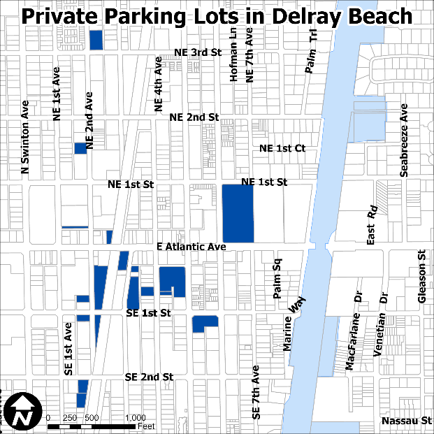
The popularity of downtown Delray Beach has given rise to privately-operated public parking lots (map at right). However, the City has received numerous reports of non-transparent and sometimes predatory practices employed by certain operators, as well as the possibility for patrons to inadvertently commit violations because of insufficient signage.

The proposed ordinance establishes signage and operational regulations for private parking lots.
Description of Proposal
The creation of a new Subsection (PP), “Private parking lots and garages” is proposed in LDR Section 4.3.3. The subsection includes regulations on:

- Required Signage
  - One sign must be located at each lot entrance, specifically indicating “Not a City-Owned Lot.”
  - Rate and operator information must be provided pursuant to F.S. 715.075.
  - Payment kiosks must be co-located with the required rate and operator signage.
  - Wheel stops may be painted to read “Not a City-Owned Lot.”
- The use of City logos is prohibited.
- When two private parking lots are adjacent, signage must clearly indicate the spaces associated with each lot operator.
- Operational requirements for maintenance and staff are proposed.
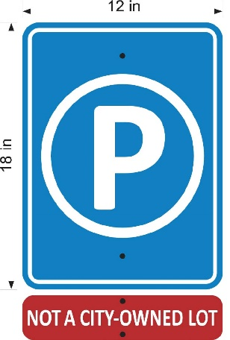 | 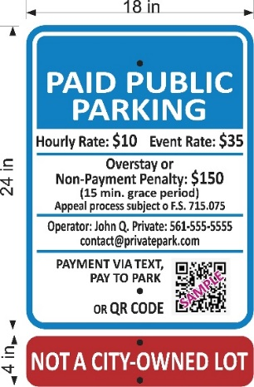
Lot Entrance Signs | Required Information Sign
- Penalties and enforcement actions on private parking lot operators for violations of the adopted regulations are added.
Images of the required signage are provided at right.

For signs in historic districts, the following language is proposed:

(6) Historic Districts. Parking lot signage in historic districts must maintain the standard blue parking symbol and contrasting NOT A City-Owned Lot signage. Post design, sign framing, and font type may be adjusted through the administrative review and approval process for consistency with the character of the district.

The proposed Ordinance No. 19-24 is provided as an attachment.

Review and Analysis
LDR Section 1.1.6, Amendments
The text of these Land Development Regulations may from time to time be amended, changed, supplemented, or repealed. No such action however, shall be taken until a recommendation is obtained from the Planning and Zoning Board and until a public hearing has been held by the City Commission.

LDR Section 2.4.7(A), Amendments to the Land Development Regulations
Amendments to the LDR may be initiated by the City Commission, Planning and Zoning Board, or City Administration, or by a member of the public.

The proposed amendment is initiated by City staff in response to direction by the City Commission.

LDR Section 2.4.7(A)(5), Findings
For any approval, the City Commission must make a finding that the text amendment is consistent with the Comprehensive Plan, and that the amendment furthers the implementation of an adopted neighborhood plan, if applicable.

The following Objectives and Policies of the adopted Comprehensive Plan are applicable to the proposed amendment.

Neighborhoods, Districts, and Corridors Element
Objective NDC 3.5, Update the Land Development Regulations Regularly review and update the Land Development Regulations to provide timely, equitable and streamlined processes including, but not limited to, building permit processes for residential developments and to accommodate mixed-use developments, address market changes and development trends, and other innovative development practices.

Policy NDC 3.5.6 Create Land Development Regulations for visual compatibility standards for nonresidential properties in historic districts.

Private parking lots have begun to proliferate in the city, but there are no regulations governing the use. The City desires to adopt regulations that promote the health, safety, and welfare of the public.

Historic Preservation Element
Policy HPE 1.4.5 Create Land Development Regulations for visual compatibility standards for non-residential properties.

The proposed regulations support the goal of visual compatibility in historic districts.

Review By Others
Downtown Development Authority. August 12, 2024, 7-0 recommendation of approval.

Historic Preservation Board. December 4, 2024, _-_ recommendation of _______.
City Commission. Ordinance No. 19-24 is anticipated to go before the City Commission for first and second reading on January 7, 2025 and January 21, 2025.
Options for Board Action
- Move a recommendation of approval of Ordinance No. 19-24, amending LDR Section 4.3.3, “Special requirements for specific uses” of the Land Development Regulations (LDR) to adopt Subsection (PP), “Private parking lots and garages,” with regulations governing such use, finding that the amendment and approval thereof is consistent with the Comprehensive Plan and meets the applicable criteria set forth in the Land Development Regulations.
- Move a recommendation of approval of Ordinance No. 19-24, amending LDR Section 4.3.3, “Special requirements for specific uses” of the Land Development Regulations (LDR) to adopt Subsection (PP), “Private parking lots and garages,” with regulations governing such use, finding that the amendment and approval thereof is consistent with the Comprehensive Plan and meets the applicable criteria set forth in the Land Development Regulations, as amended.
- Move a recommendation of denial of Ordinance No. 19-24, amending LDR Section 4.3.3, “Special requirements for specific uses” of the Land Development Regulations (LDR) to adopt Subsection (PP), “Private parking lots and garages,” with regulations governing such use, finding that the amendment and approval thereof is not consistent with the Comprehensive Plan and does not meet the applicable criteria set forth in the Land Development Regulations.
- Continue With Direction.

Public and Courtesy Notices
_X_ Courtesy Notices are not required for this request. |  | _X_ Public Notices are not required for this request

