BOARD OF ADJUSTMENT STAFF REPORT
412 SE 4th Ave
Meeting | File No. | Application Type
January 16, 2025 | 2025-071-VAR-BOA | Variance
Property Owner | Applicant / Authorized Agent
Patricia Britton and Miguel Decosta | Place Planning and Design, Inc./Corey OGorman
Request
Consideration of a variance request from Land Development Regulations (LDR) Section 4.6.15(G)(1)(a), Swimming Pool, Whirlpools, and Spas: Yard Encroachment, to allow the construction of a new swimming pool within the front setback area at a setback of 15 feet, whereas a minimum of 25 feet is required.
General Data
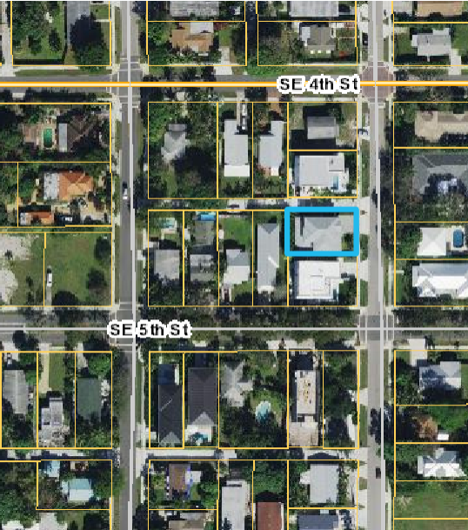
Location: 412 SE 4th Avenue

PCN: 12-43-46-21-01-004-0071

Property Size: 0.13 Acres (5,663 SF)
Land Use Designation: Low Density (LD)
Zoning District: Single Family Residential District (R-1-A)
Existing Land Use: Single Family Home
Adjacent Zoning and Uses:
  - North, South, East, and West: R-1A Single Family Residence

Legal Description: Lots 7 and 8 (less 69.58 Ft) Block 4 of the Osceola Park plat of 1919, according to the Plat thereof, recorded in Plat Book 2, Page 3 of the Public Records of Palm Beach County, Florida.

Background
The applicant purchased the property in 2016 and completed construction of a new home in 2021. The property is zoned R-1-A, requiring a minimum lot size of 7,500 SF, lot width of 60 feet and lot depth of 100 ft. The property is an existing nonconformity with a minimum lot size of 5,607 SF and a lot of width of 57.41 feet and a lot depth of 93.70 feet. During the review process of the permit, it was determined that a dedication of two feet was required for the improved alleyway to the north (side interior) of the property.

Pursuant to Land Development Regulation Section 5.3.1 Right-of-way Dimensions and Dedication required, Right-of-way dimensions and dedications, whether public or private, shall be consistent with Table MBL-1 "Street Network and Classification and Improvements" of the Mobility Element, providing for coordinated rights-of-way dedications with the Florida Department of Transportation and Palm Beach County. Table MBL-1 “Street Network Classification and Improvements requires that the ultimate right-of-way of an alley is 20 feet. The alley adjacent to the property is 16 feet thus requiring two-foot dedication.

After the dedication of the two-foot right of way, the single-family residence was constructed and met the setback requirements pursuant to LDR Section 4.3.4(K) Development Standards Matrix for the R-1-A zoning district. The applicant would like to construct a swimming pool on the southeast corner of the single-family residence in the front yard.

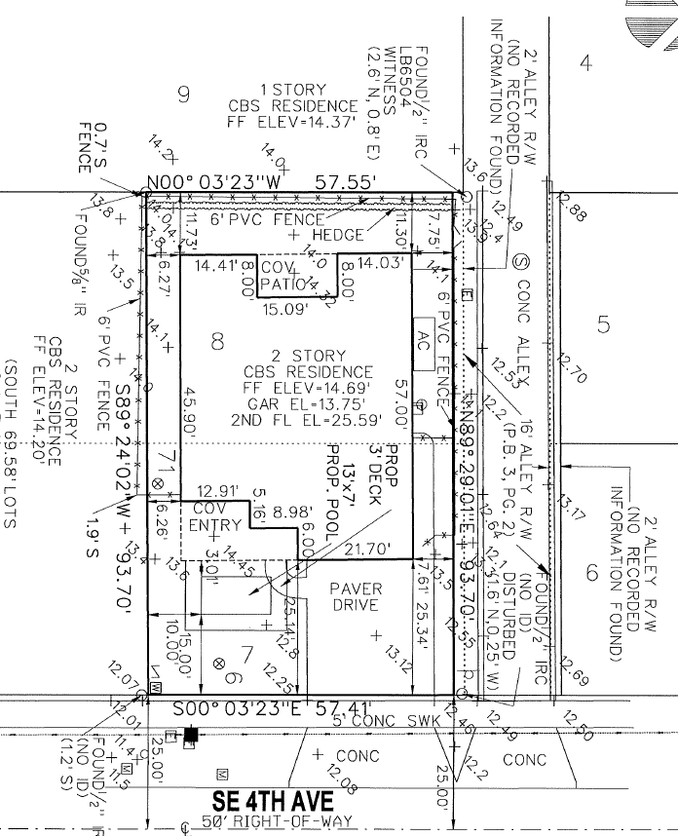

Request
The request is to reduce the minimum setback requirement for a swimming pool within the front yard to fifteen feet.

Pursuant to LDR Section 4.6.15(G)(1)(a), Swimming pools shall not extend into the front setback area required by Section 4.3.4(K). The front setback required for the R-1`-A zoning district is 25 feet. The applicant is requesting a 10 foot setback relief in the front for the construction of a swimming pool.

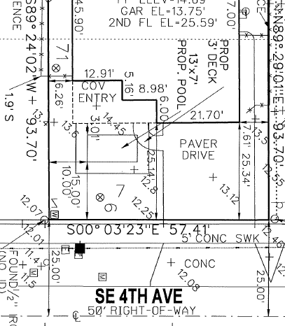
The applicant’s justification statement for the request is included as an attachment.

Variance Review and Analysis
Pursuant to LDR Section 2.1.7(E)(1)(c)(3), Board of Adjustment: Duties, powers, and responsibility, Supplemental District Regulations, Article 4.6, for single-family or duplex uses, unless otherwise stated, except where said authority is expressly prohibited, granted to others, or relief is available through another process.
The requested relief is from a requirement in Article 4.6 – Section 4.6.15(G)(1), Swimming pool, whirlpools, and spas: Yard Encroachment, states, “swimming pools shall not extend into the front setback area noted in Section 4.3.4(K).”

Pursuant to LDR Section 2.4.11(A)(5)(a-f), Variance Findings, the following findings must be made prior to the approval of a variance:

- That special conditions and circumstances exist which are peculiar to the land, structure, or building involved and which are not generally applicable to other lands, structures, or buildings subject to the same zoning (The matter of economic hardship shall not constitute a basis for the granting of a variance);

- That literal interpretation of the regulations would deprive the applicant of rights commonly enjoyed by other properties subject to the same zoning;

- That the special conditions and circumstances have not resulted from actions of the applicant;

- That granting the variance will not confer onto the applicant any special privilege that is denied to other lands, structures, and buildings under the same zoning. Neither the permitted, nor nonconforming use, of neighborhood lands, structures, or buildings under the same zoning shall be considered grounds for the issuance of a variance;

- That the reasons set forth in the variance petition justify the granting of the variance, and that the variance is the minimum variance that will make possible the reasonable use of the land, building, or structure; and,

- That the granting of the variance will be in harmony with the general purpose and intent of existing regulations, will not be injurious to the neighborhood, or otherwise detrimental to the public welfare.

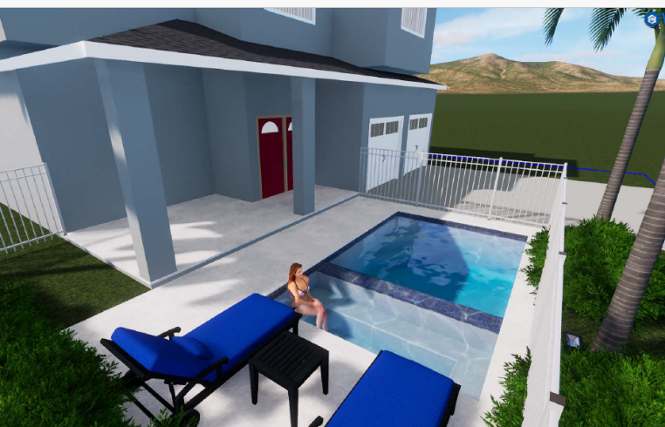
In consideration of the criteria listed above, the Board must consider whether special conditions or circumstances exist that are relative to the property, and if the granting of the variance for the pool to encroach 10 feet into the front yard will not confer onto the applicant any special privilege that has been denied in similar request. While there have been variances granted for pools in the front yard setback area for other residential requests, LDR Section 4.6.15(G)(1), Yard Encroachment, is applied city-wide. The intent of the requirement is to not have swimming pools located within the front setback area as to maintain an open streetscape within residential neighborhoods. The applicant has provided examples in their justification statement of other properties within the City that received variances in the past for the installation of a swimming pool within the front setback. Each variance request stands on its own and should be considered whether special conditions or circumstances apply to the subject property requesting relief.

The board should also consider if the variance petition justifies that the granting of the variance is the minimum variance that will make possible the reasonable use of the land. However, the illustration below shows that the properties to the north and south of the subject property installed a swimming pool in the front yard without relief.
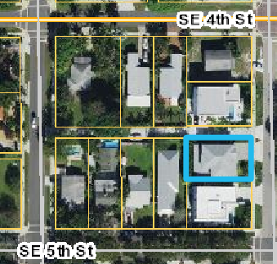

The board should consider if the request to construct a pool 10-foot into the front yard is a result of actions by the applicant and if the literal interpretation of the regulations would deprive the applicant of rights commonly enjoyed by other properties subject to the same zoning. The applicant demolished the existing structure and constructed a new single-family residence. The right of way dimensions and dedications are required city wide provided in Table MBL-1 of the Always Delray Comprehensive Plan for the street network whenever new construction is proposed.

The granting of the variance is not anticipated to conflict with or be detrimental to the existing neighborhood. The applicant is providing a fence that is required pursuant to LDR Section 4.6.15(A)Enclosures required for private pools; All private or family type pools, except those defined in (D) of this Section, shall be enclosed by fence or other enclosures so that the premises upon which the pool is located are enclosed from adjoining yards or property.

Optional Board Actions
- Move approval of the Variance request for 412 SE 4th Avenue (2025-071 VAR-BOA) from LDR Section 4.6.15(G)(1) to allow the construction of a new swimming pool within the front setback area at a setback of 15 feet, whereas a minimum of 25 feet is required by finding that the request is consistent with the findings set forth in LDR Section 2.4.11(A)(5)(a-f),

- Move denial of the Variance request for 412 SE 4th Avenue (2025-071 VAR-BOA) from LDR Section 4.6.15(G)(1) to allow the construction of a new swimming pool within the front setback area at a setback of 15 feet, whereas a minimum of 25 feet is required by finding that the request is not consistent with the findings set forth in LDR Section 2.4.11(A)(5)(a-f),
- Move to continue with direction

Public Notice
Pursuant to LDR Section 2.6.3(G), Notice in accordance with Section 2.6.2 (A), (B), (C), and (D) shall be provided prior to a Public Hearing.
LDR section | Date Posted
2.4.2 (B)(1)(j)(i) - Written notice provided to property owners within 500 feet | January 3, 2025
2.4.2 (B)(1)(j)(ii) - Notice posted on the City's web page at least ten days prior | January 3, 2025
2.4.2 (B)(1)(j)(iv) - Notice posted at City Hall | January 3, 2025

