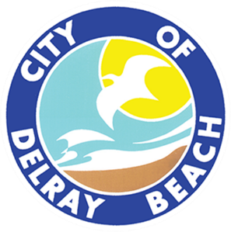
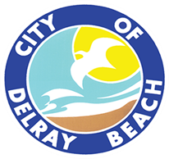
CITY OF DELRAY BEACH
CITY ATTORNEY’S OFFICE
200 NW 1ST Avenue, Delray Beach, FL 33444
561-243-7090

LEGAL REVIEW FORM

This form is to be used solely for the legal review of documents not including procurement agreements. Procurement Agreements are reviewed under a separate cover. This form shall only be completed by a member of the City Attorney’s Office.
Date of Review: 4/24/25

Document Name: Resolution 58-25, In-lieu of Parking Request Swinton Social

Document Type: In-Lieu Resolution

Submitted by: Katherina Paliwoda

This document is approved as to form and legal sufficiency.

This document is approved as to form and legal sufficiency; however, the undersigned made the

following change(s):

This document is not approved as to form and legal sufficiency for the following reason(s):

________________________________________________________________________________.

s/Kelly W. Brandon, Esq.
Attorney

Copy to:
_ City Attorney’s Office (with a copy of the approved document)

