PLANNING AND ZONING BOARD STAFF REPORT
Standalone Retail Tobacco and Nicotine Products Dealers
Meeting | File No. |  | Application Type
April 21, 2025 | 2025-093-LDR |  | Amendment to the Land Development Regulations
Applicant | Agent |  | Property Owner
City of Delray Beach | Not applicable. |  | Not applicable.
Request
Provide a recommendation to the City Commission on Ordinance No. 04-25, a City-initiated amendment to Appendix A, “Definitions” to adopt a definition of Retail Tobacco and Nicotine Products Dealer, Section 4.3.3, “Special Requirements for Specific Uses” to adopt Subsection (DDD), “Retail Tobacco and Nicotine Products Dealer,” and Section 4.4.13, “Central Business (CBD) District” to adopt additional regulations governing the frequency of such use.
Background Information
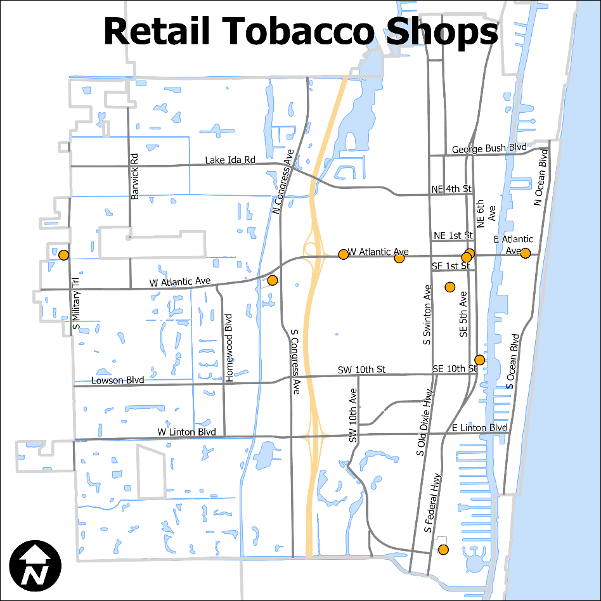
Standalone retail tobacco and nicotine dealers have begun to proliferate, particularly in the downtown (map at right). This is at cross-purposes to the goals of the Central Business (CBD) District in Section 4.4.13, Land Development Regulations, particularly related to developing a balanced mix of uses that will help the area evolve into a traditional, self-sufficient downtown and encouraging a mix of residential, commercial and civic functions and businesses that are oriented toward serving the local neighborhood.

The over-concentration of this use has the potential to negatively impact the downtown in particular, due to the compact lot and block structure. However, the proliferation of retail tobacco dealers is not desirable in any location, particularly adjacent to potentially incompatible uses such as schools or parks, due to the documented negative public health impacts of tobacco use.

It should be noted that the distinction between tobacco products accessories and drug paraphernalia is often blurred, such that retail tobacco dealers often sell and prominently display items not traditionally associated with tobacco use (such as water pipes) are sold and marketed for use with tobacco products. As such, these smoking devices cannot be classified as drug paraphernalia; a wholesale ban within the city is not possible.

Currently, there are no special requirements for this specific use. Therefore, Ordinance No. 04-25 proposes regulations to prevent the over-concentration of retail tobacco dealers and limit any potential negative impacts on the public welfare.

Description of Proposal
The regulations proposed in Ordinance No. 04-25 are as follows:

Appendix A, “Definitions”

[NEW Definition] retail tobacco or nicotine products DEALER. A licensee of the Florida Department of Business and Professional Regulation authorized to engage in the retail sale of tobacco products and nicotine products to consumers.

Section 4.3.3, “Special Requirements for Specific Uses”

- [NEW] Subsection (DDD), “Retail Tobacco and Nicotine Products Dealer”

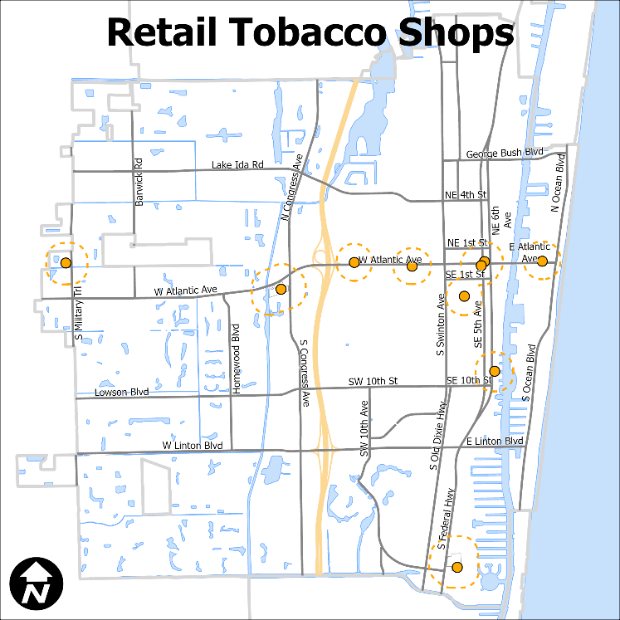
- Prohibition by Frequency. Standalone retail tobacco and nicotine products dealers shall not be located within 750 feet of each other (map at right).

- Prohibition by Proximity. Standalone retail tobacco and nicotine product dealers shall not be located within 300 feet of an established residential zone, school, public park, day care facility, or place of worship as measured from property line to property line (map below).

These proposed restrictions do not apply to a duly licensed grocery store, convenience store, or pharmacy that sells tobacco and nicotine products.
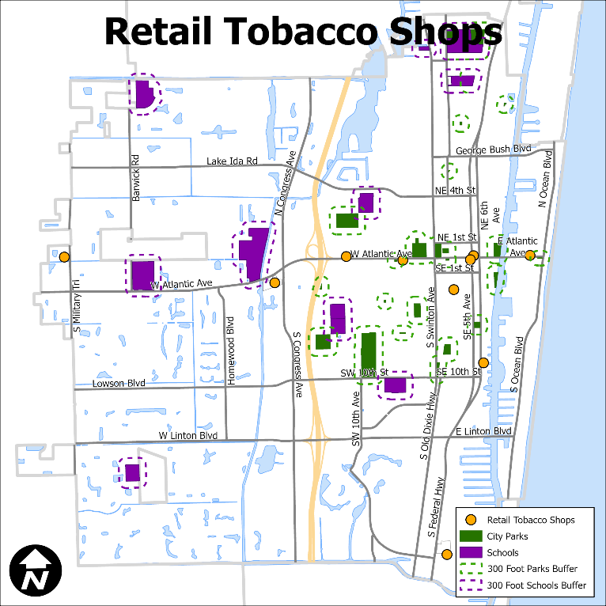
- CBD Oil. The sale of cannabidiol products is regulated by Section 4.3.3(CC), with such regulations determining if cannabidiol products may be sold by a standalone retail tobacco and nicotine products dealer.

- Window Displays. Window displays of tobacco and nicotine products and accessories are prohibited.

- Hours of operation. Standalone retail tobacco and nicotine product dealers are limited to operating between 8 a.m. to 10 p.m.

It should be noted that the separation requirements would only apply to new standalone retail tobacco dealers.

LDR Section 4.4.13, “Central Business (CBD) District”

- No more than one standalone retail tobacco or nicotine products dealer is allowed per block, and products may not be displayed in the window. Additional and related regulations in Section 4.3.3(DDD) apply.

This additional per-block limitation is applied, due to the varying block lengths within the CBD; if only the 750 foot separation applied, two standalone retail tobacco or nicotine products dealers could theoretically locate on the same block. The one per block regulation prevents that possibility.

Although downtown Delray has particular characteristics that should be preserved, they are more closely related to form rather than use; a wholesale prohibition of the use on Atlantic Avenue and Pineapple Grove Way would perhaps unfairly shift the distribution of the use to other districts in the city. The proposed distance separation is consistent with the separation requirements for other uses such as CBD oil and standalone bars.

Review and Analysis
LDR Section 1.1.6, Amendments
The text of these Land Development Regulations may from time to time be amended, changed, supplemented, or repealed. No such action however, shall be taken until a recommendation is obtained from the Planning and Zoning Board and until a public hearing has been held by the City Commission.

LDR Section 2.4.7(A), Amendments to the Land Development Regulations
Amendments to the LDR may be initiated by the City Commission, Planning and Zoning Board, or City Administration, or by a member of the public.

The proposed amendment is initiated by Development Services.

LDR Section 2.4.7(A)(5), Findings
For any approval, the City Commission must make a finding that the text amendment is consistent with the Comprehensive Plan, and that the amendment furthers the implementation of an adopted neighborhood plan, if applicable.

The following Goals, Objectives, and Policies of the adopted Comprehensive Plan are applicable to the proposed amendment.

Neighborhoods, Districts, and Corridors Element
Objective NDC 2.2 Downtown and Surrounding Neighborhoods Protect and enhance the “Village by the Sea” character of the downtown and neighborhoods located east of I-95.

Objective NDC 3.5, Update the Land Development Regulations Regularly review and update the Land Development Regulations to provide timely, equitable and streamlined processes including, but not limited to, building permit processes for residential developments and to accommodate mixed-use developments, address market changes and development trends, and other innovative development practices.

The continued health of the downtown area is essential to preserving the charm, character, and historic scale of downtown. The proposed amendment supports the preservation of a balanced mix of uses that characterize a traditional, self-sufficient downtown, rather than the over-concentration of an industry that has begun to proliferate.

Healthy Community Element
Goal HCE 3 Reduction of Health Risk Factors Reduce exposure to health risk factors at home, the environment, and society.

Regulating the location of standalone retail tobacco and nicotine dealers by prohibiting proximity to schools and parks supports the reduction of exposure to health risk factors for children and teens.

Staff conducted research on whether other nearby jurisdictions (Boca Raton, Boynton Beach, Greenacres, Royal Palm Beach, West Palm Beach, Wellington, Lantana, Palm Beach Gardens, Jupiter, Miami, Fort Lauderdale, Lauderhill, Deerfield Beach, North Palm Beach, and Riviera Beach) specifically regulate retail tobacco sales. Deerfield Beach and Lauderhill are the only cities evaluated that specifically regulate retail tobacco shops. Deerfield Beach establishes a 1,000 foot separation between “smoke shops” and houses of worship, licensed day care centers, medical clinics or specialty hospitals treating persons for substance abuse and 100 feet of separation from any residentially zoned property, alcoholic beverage establishment, nightclub or private club. The City of Lauderhill limits the sale of smoking pipes, smoking devices, drug paraphernalia and scales to 50 percent of the total inventory, with quarterly reporting requirements. A discussion with City staff, however, indicates that quarterly reporting is not being enforced, being an impractical and onerous requirement. Sales thresholds and regular reporting requirements are also not feasible, based on feedback from staff in other jurisdictions.

Thus, the proposed regulations are designed to be both defensible and implementable. The separation proposed in Ordinance No. 04-25 mirrors the restrictions applicable to CBD oil retailers; any greater restriction on tobacco sales would be inconsistent with current practice.

Reviewing Boards
Downtown Development Authority. DDA reviewed the proposed amendment on February 10, 2025 and recommended approval with a number of changes:

- Prohibit any sale of water pipes;
- Adopt language to establish a percentage threshold for retail tobacco and nicotine product sales, that would trigger compliance with the regulations for standalone retail tobacco and nicotine products dealers; and.
- Prohibit standalone retail tobacco and nicotine dealers on Pineapple Grove Way and Atlantic Avenue.

Options for Board Action
- Recommend approval to the City Commission on Ordinance No. 04-25, a City-initiated amendment to Appendix A, “Definitions” to adopt a definition of retail tobacco and nicotine dealers, Section 4.3.3, “Special Requirements for Specific Uses” to adopt Subsection (DDD), “Retail Tobacco and Nicotine Products Dealer,” and Section 4.4.13, “Central Business (CBD) District” to adopt regulations governing the frequency of such use, by finding that the amendment and approval thereof is consistent with the Comprehensive Plan and meets the criteria set forth in Land Development Regulations.

- Recommend approval to the City Commission of Ordinance No. 04-25, as amended, a City-initiated amendment to Appendix A, “Definitions” to adopt a definition of retail tobacco and nicotine dealers, Section 4.3.3, “Special Requirements for Specific Uses” to adopt Subsection (DDD), “Retail Tobacco and Nicotine Products Dealer,” and Section 4.4.13, “Central Business (CBD) District” to adopt regulations governing the frequency of such use, by finding that the amendment and approval thereof is consistent with the Comprehensive Plan and meets the criteria set forth in Land Development Regulations.

- Recommend denial to the City Commission of Ordinance No. 04-25, a City-initiated amendment to Appendix A, “Definitions” to adopt a definition of retail tobacco and nicotine dealers, Section 4.3.3, “Special Requirements for Specific Uses” to adopt Subsection (DDD), “Retail Tobacco and Nicotine Products Dealer,” and Section 4.4.13, “Central Business (CBD) District” to adopt regulations governing the frequency of such use, by finding that the amendment and approval thereof is not consistent with the Comprehensive Plan and does not meet the criteria set forth in Land Development Regulations.

- Continue with direction.
Public and Courtesy Notices
_X_ Courtesy Notices are not required. |  | _X_ Public Notices are not required for this request.

