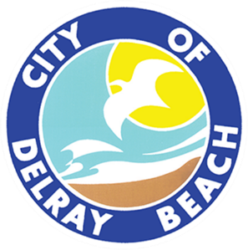
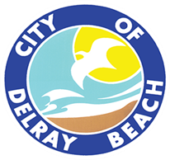
CITY OF DELRAY BEACH
CITY ATTORNEY’S OFFICE
200 NW 1ST Avenue, Delray Beach, FL 33444
561-243-7090

LEGAL REVIEW FORM

This form is to be used solely for the legal review of documents not including procurement agreements. Procurement Agreements are reviewed under a separate cover. This form shall only be completed by a member of the City Attorney’s Office.
Date of Review: 04/25/2025

Document Name: Resolution 60-25

Document Type: Resolution to be utilized if City Commission approves the in-lieu of parking request for the property located at 50 SE 4th Avenue.

Submitted by: Susana Rodrigues

This document is approved as to form and legal sufficiency.

This document is approved as to form and legal sufficiency; however, the undersigned made the

following change(s):

This document is not approved as to form and legal sufficiency for the following reason(s):

________________________________________________________________________________.

Notes:

s/William M. Bennett, Esq.
Assistant City Attorney

Copy to:
_ City Attorney’s Office (with a copy of the approved document)
X Other: Susana Rodrigues

